20/4/2020
Find the equation of the line passing through the point (√3 , 4) and inclined at an angle of 60° with the positive x-axis.

Given that tan 15° = -√3+2 , find the equation of the line passing through the origin, inclined at an angle of 75° with the positive x-axis.

Lines L1 and L2 have equations x + y = 10 and y=$\frac{4x}{5}$ – 3 respectively. Find the acute angle between these 2 lines.

The curve y = 1+$\frac{1}{x-2}$ is transformed into y = –1+$\frac{1}{x+2}$ . State the sequence of transformations involved.

A curve with the equation y=√x is transformed into y=k(√(ax+b) + c. State the values of k, a, b and c.
[b] A dilation parallel to the positive x-axis of factor 2 followed by a translation 5 units in the direction of the positive x-axis.
Answers: k=1, a=1/2, b=-5/2, c=0.
[c] A translation 5 units in the direction of the negative y-axis followed by a reflection about the x-axis.
Answers: k=-1, a=1, b=0, c=5.

The circle with equation (x+6) + (y–7) = 81 is transformed into the circle with equation (x–a)² + (y–b)² = r² by a dilation of factor 2 parallel to the x-axis followed by a dilation of factor 2 parallel to the y-axis. State the values of a, b and r.
Answers: a=12, b=14, r=18.
25/4/2020
If tan A = 5√3 and tan B = – $\frac{\sqrt{3}}{4}$ , find the value of tan (A+B).
If $π$ ≤ (A+B) ≤ 2$π$ determine (A+B).

Identify the sequence of transformations required to map y = f(x) to
y = f(1–x)
Answer: Translate 1 unit left and reflect about the y-axis.

Given that f(x) = x², solve f(x) = f(2x+1). Describe clearly how you obtained your answer.
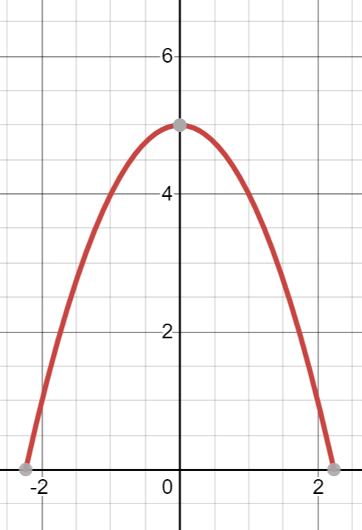
The sketch of y = f(x) is given in the accompanying diagram:
Sketch y = f( $\frac{x}{2}$+1)

How do you use a Classpad calculator for transformations?

A white crystalline solid of molecular formula C_{x}H_{y}O_{z} was isolated from certain fruits. When 0.682 g of the compound was combusted with oxygen gas, it produced 0.968 g of carbon dioxide gas and 0.594 g of water. Determine the empirical formula and, hence, the molecular formula of the substance if it has a molecular mass of 62.3 g mol⁻¹.

32.7 g of aluminium is reacted with 131 g of chlorine to produce aluminium chloride. Determine:
[a] The limiting reagent.
[b] The mass of aluminium chloride produced.
[c] The mass of excess reagent left over.

0.035 moles of HCI reacts with 2.5 g of CaCO₃.
[a] How many moles of CO₂ are formed?
[b] Determine the limiting reagent.

Balance the following equation:
H₂O _{(l)} O_{2 (g)} + H₂O _{(l)}

Consider the fuels octane and butane. Their heats of combustion are 5471 kJ mol⁻¹ for octane and 2878 kJ mol⁻¹ for butane.
[a] Write the equation for the combustion of butane and octane.
[b] Determine the energy produced per kg of each fuel.
[c] Determine the moles of carbon dioxide produced per MJ of energy produced in each case.
[d] Use your results to compare these fuels.

27/4/2020
2NH_{3 (g)} + H₂SO_{4 (aq)} (NH₄)₂SO_{4 (aq)}
[a] Calculate the mass of ammonia sulfate that could be produced from 25kL of ammonia gas at STP.
[b] What mass of sulfuric acid would be required?

Aluminium metal reacts with hydrochloric acid to produce aluminium chloride and hydrogen gas. If a student wanted to produce 500mL of this gas at STP, determine the mass of aluminium required.

Describe a sequence of transformations required to convert f(x) = (2x+1)² to g(x) = x².
Answer: Dilate parallel to the x-axis by a scale factor of 2 and translate 1 unit right.

Describe a sequence of transformations required to convert y = f(x) to y = f(1-x).
Answer: Reflect about the y-axis and translate 1 unit left.

The curve y = f(x) has a minimum turning point at (–2, -1) and a maximum turning point at (4, 6) Find the minimum and maximum turning points of y = f(1–x).
Answers: Minimum turning point is (3, 1) and the maximum turning point is (–3, 6).

If tan A = 5√3 and tan B = – $\frac{\sqrt{3}}{4}$ , find the value of tan (A+B).
If $π$ ≤ (A+B) ≤ 2$π$ determine (A+B).

2/5/2020
Prove the following:
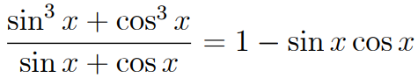

The radioisotope phosphorus-32 has a half-life of 14.3 days and decays to a stable product. Sam, a nuclear technician, prepared a sample of this isotope with an initial activity of 2.30 MBq. What was the activity of the sample 42.9 days later?

The half-life of a radioactive cobalt-60 source radiographers use for medical irradiation is 5.30 years. If the activity of a new source is 800 GBq, what is its activity after 26.0 years?

Simplify the following:
[a] 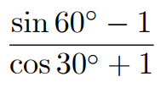
Answer:
[b] 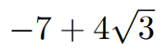
Answer:
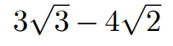

4/5/2020
Engineers use the radioisotope gold-198, a beta emitter, to track sewerage. Determine the amount to energy released by one decay of gold-198.

Emphysema is a disease which affects the alveoli and may be caused by long-term exposure to tobacco smoke. Explain how this disease affects the efficiency of the respiratory system and any of the symptoms the person is likely to experience?

Single-celled bacterium do not require a circulatory system, however large multicellular animals do. Explain why this is so; and how the circulatory system delivers oxygen and nutrients to and removes waste from the cells of the human body.

Compare the circulatory and lymphatic system of the body. In your response, refer specifically to the contents of the fluid that is transported in each system and the function of this fluid in each system.

Explain why someone with an infected toe may experience a lump in his or her groin.
The respiratory surface in the lungs is designed to maximise gas exchange. Identify and explain 5 features of the lung’s respiratory surface that allow for maximum gas exchange.

Describe 4 key structural and functional features of arteries and describe four (4) key structural and functional features of veins.

Outline the pathway taken by a red blood cell through the heart. Start at the point where the blood returns to the heart via the vena cava and finish where the blood leaves the heart via the aorta. Include in your answer the events that occur along the pathway.

9/5/2020
A small proportion of all carbon in living organisms is the radioactive isotope carbon-14. Calculate the binding energy per nucleon of both the carbon-12 and carbon-14 nuclei and hence state which is more stable.
Answer: C-12 has a greater binding energy per nucleon, so it is more stable.

Ilmenite contains 53.5% of TiO₂.
[a] Calculate the percentage of Ti in TiO₂.
[b] What mass of ilmenite must be refined to produce 1.00 tonne of pure titanium metal?
Answer: 3.12 tonnes.

When a particles and its anti-particle collide they annihilate each other and all of their mass is converted to gamma ray photons. How much gamma ray energy was released in one such collision between a proton and an anti-proton as the universe was forming?
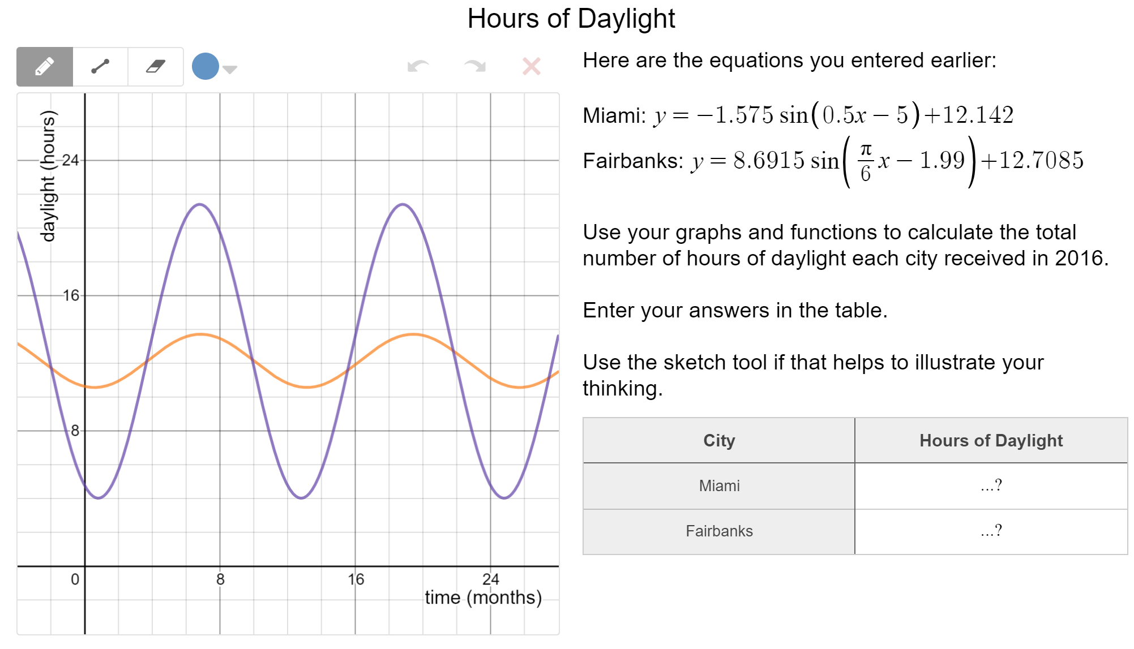

11/5/2020
Explain what happens to the resistance of a component at higher currents.
Answer: The resistance of the component increases exponentially.
150Ω
300Ω

12V

What is the least and greatest current this circuit can achieve? (ammeter is 2Ω).
Answer: R_{T} = 2Ω (rheostat = 0 creates a short circuit) Greatest = 12/2=6A
R_{T} = 2 + (300⁻¹ + 150⁻¹)⁻¹ = 102 Least = 12/102 = 1.18 x 10⁻¹ A
Andrew foolishly uses a metal-handled knife to remove a burning slice of bread from his toaster. The knife touches the toaster element, which carries 240V AC. Fortunately for him, an RCD is installed in his home. His body resistance would allow 40.0mA of current to pass through him to the earth. This is enough current to trip the RCD which switches off all power in his house.
[a] What was the total resistance of Andrew’s body, shoes and floor?
[b] If the current was 1.50A in the active line, what would the ‘return current’ in the neutral line be for the RCD to detect the difference?

16/5/2020
State 2 possible equations for a circle with radius 5 and passing through the point with coordinates (4 , 4).

Find all possible equations of a cubic curve with roots x = 1, 2, –3 and vertical intercept (0 , 12).
Answer: y = 2(x–1)(x–2)(x+3)
(Why can’t it also be y = (x–1)(x–2)(x+3) + 6)?)

Find all possible equations of a cubic curve with roots x = –2 and x = 4 and vertical intercept (0 , 16).
Answer: y = $\frac{1}{2}$ (x+2)(x–4)²
(Why can’t it also be y = –(x+2)²(x–4)?)

Consider the equation y = f(x) = k(x+2)(x²–3x+c) where k and c are constants. Find the values of k and c if f(–4) = f(–2) = 0 and f(0) = –4.

Why can’t I choose “intersection” on my Classpad?

Lines L1 and L2 have equations x + y = 10 and y = $\frac{4x}{5}$ – 3 respectively. Find the acute angle between these 2 lines.
Why do we use tan⁻¹(1) instead of tan⁻¹(–1)?

A small light globe is marked 17 mA, 4W. Is it a household lamp or for a car? What’s the evidence for your answer?

Is it normal to have a lot more notes on atomic absorption spectrometry and mass spectrometry, but a comparatively much smaller amount of notes on atomic emission spectrometry?

If it costs $800 to insulate the roof of a small apartment, with the result that the 4000W air conditioner, when needed, is operated for an average of 3 hours less per day:
[a] Calculate how many days’ use it will take for the electrical savings to cover the cost of the insulation.
[b] Hence estimate how long it will take (in weeks, months or years) for the electrical savings to cover the cost of the insulation.

A student sets up circuit A as shown in the diagram. The ammeter in the circuit reads 6.00A. She then uses 2 globes identical to the one in the above circuit to connect circuit B as shown in the diagram. Assume the resistance of the ammeter is negligible.

6.00A

[b] What readings would she find on the 3 ammeters in circuit B?
Answers: A1=12A, A2=6A, A3=6A.
Does it mention that the globes are 2Ω?

18/5/2020
State the 2 possible equations for the curve with equation y = a + k$\sqrt{x+b}$ if the curve has x ≤ 2 and y ≤ –3.
Answer: Any 2 equations of the form y = –3 + k$\sqrt{2-x}$ for k < 0.
(If the asymptote is y = –3, shouldn’t it be y ≥ –3?)

The parabola with equation y² = x is transformed into the parabola with equation y² = k(x–a) by a reflection about the y-axis followed by a reflection about the x-axis. State the values of a and k.

23/5/2020
The preparation of oxygen in the laboratory can be conveniently achieved by the catalytic decomposition (using MnO₂) of hydrogen peroxide.
MnO₂
2H₂O_{2 (aq)} O_{2 (g)} + 2H₂O _{(l)}
[a] What mass of hydrogen peroxide is needed to produce 3.47g of oxygen gas?
Answer: m(H₂O₂) = 7.38g.
[b] What mass of hydrogen peroxide solution is needed if the solution contains 18.5% by weight of hydrogen peroxide?
Answer: % H₂O₂ = $\frac{m\left(H2O2\right) x 100}{m(H2O2 solution)}$ m(H₂O₂) = $\frac{7.38 x 100}{18.5}$ = 39.9g.

During normal breathing an adult will, on average, inhale 0.50L of air per breath. Although oxygen makes up 21% of the inhaled air, only 25% of this is absorbed into the bloodstream from each breath.
Cellular respiration:
C₆H₁₂O_{2(g)} + 6O_{2(g)} 6CO_{2(g)} + 6H₂O_{(l)}
[a] Determine the STP volume of oxygen used to metabolise 8.5g of glucose.
[b] Approximately what number of breaths would be needed to supply this much oxygen to your body cells?
Answer: 240 breaths (2 significant figures).

Sodium hydroxide and sulfuric acid react by the neutralisation reaction shown here:
H₂SO_{4(aq)} + 2NaOH_{(aq)} Na₂SO_{4(aq)} + 2H₂O_{(l)}
In a particular experiment, a solution containing 5.240g of sodium hydroxide is added to another solution containing 0.1640 mol of sulfuric acid. Determine the mass of sodium sulfate formed.
Answer: NaOH is the limiting reagent. Mass of sodium sulfate = 1.931g.
(Isn’t H₂SO₄ the limiting reagent?)
25/5/2020
Consider the fuels octane and butane. Their heats of combustion are 5471 kJ mol⁻¹ for octane and 2878 kJ mol⁻¹ for butane.
[a] Write the equation for the combustion of butane and octane.
[b] Determine the energy produced per kg of each fuel.
[c] Determine the moles of carbon dioxide produced per MJ of energy produced in each case.
[d] Use your results to compare these fuels.

It was found that 36g of carbon contained 3 times as many atoms as 108g of silver.
[a] Which element has the heaviest atoms?
[b] By what factor are they heavier?

An excess quantity of zinc metal is placed in a solution containing 125mL of concentrated nitric acid (6.0 mol L⁻¹). The equation for the reaction is:
Zn_{(s)} + 2NO₃–_{(aq)} + 4H⁺_{(aq)} Zn²⁺_{(aq)} + 2NO_{2(g)} + 2H₂O_{(l)}

Assuming all the nitric acid reacted with the zinc as shown in the equation above, determine:
[a] Mass of zinc that reacted.
[b] Mass of zinc nitrate that could be recovered from solution.

A solution containing 200mL of 1.0 mol L⁻¹ sodium carbonate solution is added to 200mL of 1.0 mol L⁻¹ barium chloride solution.
[a] Will a precipitate form? If so, write an equation for the reaction.
[b] Calculate the mass of any precipitate.
[c] Determine the concentration of any remaining ions in solution.
(Hint: Check solubility table).

30/5/2020
A camper wants to use water to remove 2.93MJ of heat from an overheated metal barbecue plate. The water they want to use has a temperature of 20°C. What’s the smallest mass of water the camper can use without the water boiling?

Ahmed is a heating consultant. One of his clients has a boiler that’s 62% efficient and uses heating oil that releases 4.15 x 10⁷ J kg⁻¹ of heat energy when it burns in air. What mass of heating oil does the boiler need to heat 245kg of water from 12.0°C to 68.0°C?

If a student is randomly selected from the Year 12 students in a particular school. the probability of that student being male is 0.52, the probability that they study Chemistry is 0.44 and the probability of them being female and not doing Chemistry is 0.18.
Determine the probability that the selected student is:
[a] A female studying Chemistry.
[b] A male not studying Chemistry.

In different parts of a car air conditioner, a liquid changes to a gas, and a gas changed to a liquid. Describe how the air conditioner removes heat from the car’s cabin.

Is this correct:

Use latent heat of vaporisation
Use latent heat of fusion

Solid Liquid Gas

Use latent heat of vaporisation
Use latent heat of fusion

1/6/2020
The lines 2x + 3y = 12 and 4x + 5y = 20 meet at the point P. Find the point P.
(The answers solved it simultaneously by multiplying the first equation by 2 to solve for ‘y’, but can’t I just solve for ‘x’?)

A parabola with equation $y=a(x-b)(x+c)$ has turning point at $\left(2, -8\right)$ and y-intercept at $\left(0, -6\right)$. The constants a, b and c are all positive.
[a] Determine the values of the positive constants $a, b$ and $c$.
[b] The parabola is translated $10$ units to the left and $5$ units downwards. Determine the equation of the transformed parabola in the form $y=a{\left(x-p\right)}^{2}+q$.

The sides adjacent to the right-angle in a right triangle have lengths $65$ cm and $72$ cm.

If the smallest angle in the triangle is $α$, determine an exact value for tan$α$.
Answer: $\frac{65}{72}$
(Can’t it also be $\frac{72}{65}$ ?)

A small weight, attached to the bottom of a spring, oscillated up and down. The distance, d cm, of the weight from the top of the spring after t seconds can be modelled by:
$$d=45+35\sin{(\frac{3πt}{4}})$$
[a] Sketch the graph on the axes below for 0 ≤ x ≤3.
Answer:
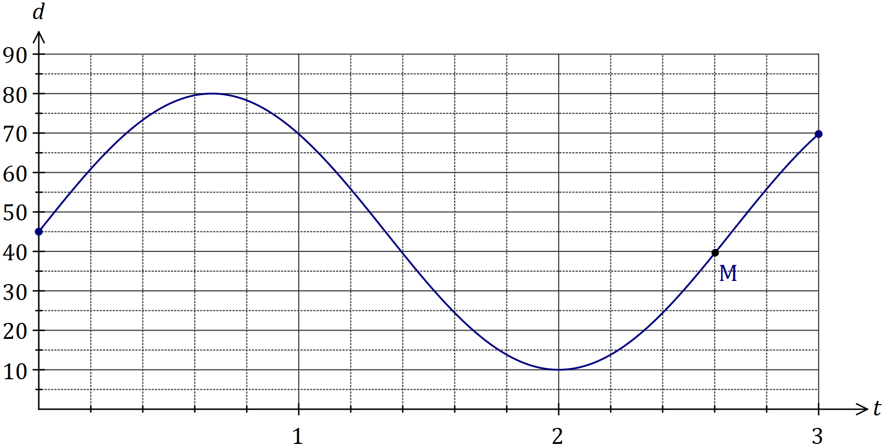
[b] Mark on your graph point M, where the weight is 40cm from the top of the spring and moving downwards.

[c] Determine:
(i) The maximum distance of the weight from the top of the spring.
Answer: 80cm

(ii) The time taken for the spring to return to its initial position.
Answer: t = $\frac{4}{3}$ = 1.35 seconds

(iii) The distance moved by the weight between t = 1 and t = 2.
Answer: d(1) – d(2) = 69.75 – 10 = 59.75cm

The graph of y = f(x) is shown below, where f(x) = is shown below, where f(x) = sin(x+c) and c is a constant.
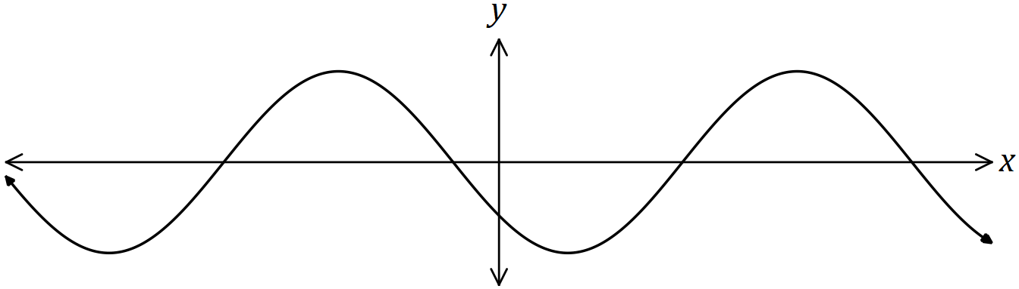
Explain how to obtain the graph of each function below from the graph of f(x), given that a and b are also constants.
[a] y = sin(x+a).
Answer: Translate horizontally by (c–a) units.

[b] y = cos(x+b).
Answer: Translate horizontally by (c–b–$\frac{π}{2}$) units.

Briefly describe the behaviour of the y values for the following, given the behaviour of the x values:
y = $\frac{1}{x}$ , as x → –∞
Answer: y → 0

Line L has equation $\frac{x}{4}+ \frac{y}{5}=1$.
[a] Determine the equation of line P that’s perpendicular to L and passes through the point with coordinates (50, 4).
[b] Determine the coordinates of the point of intersection of L and P.
Answer: (20, –20)

In different parts of a car air conditioner, a liquid changes to a gas, and a gas changed to a liquid. Describe how the air conditioner removes heat from the car’s cabin.
Is this explanation correct:

The volatile liquid evaporates as it passes through the cabin, absorbing the latent heat of vaporisation from its surroundings and hence cooling the interior. Outside the cabin, the volatile liquid, which is now a gas, is compressed, causing it to condense and release the latent heat of vaporisation which it absorbed to its surroundings (outside the cabin). The process then repeats.

Steamers are vessels you can use to cook food in. Food in the steamer gains heat as the steam condenses on it. A boiler supplies steam at 105°C to a steamer at the rate of 455g min⁻¹. Calculate the rate (in J s⁻¹) at which the steam supplies heat to the food if the steam cools, then condenses to water at 100.0°C.
Answer: 1.72 x 10⁴ J s⁻¹

A foundry operator finds that it takes 55.6MJ of heat to heat a 286kg mass of an alloy steel from 22.0°C to 452°C. If the foundry worker cools the steel by pouring water onto it, the water will heat up to its boiling point, then it will boil. What minimum mass of water, initially at 22.0°C, would cool the hot steel down to 100°C?
(The answers used Q = mcΔt but shouldn’t we use mcΔt = mcΔt?)
At 3 pm, the length of the shadow of a thin vertical pole standing on level ground is the same as the height of the pole. A while later, the angle of elevation of the sun has decreased by 12° and the length of the shadow has increased by 95 cm. Determine the height of the pole.
Answer: 176cm.

A running track has circular ends of radius 100 m and two straight, parallel sides $PQ$ and $RS$ that are both 120 m long, as shown below. Determine, to the nearest metre, the total length of the track.
The diagram shows a circle with centre $O$ and diameter $BC$, and an equilateral triangle $ABC$. Determine the exact fraction of the area of the circle that lies outside the triangle.
Answer:
Answer:
The quadratic function $h\left(t\right)=-5t^{2}+180$ for $t≥0$ describes the height, $h$metres, above ground level of a falling tennis ball after $t$ seconds
For how long was the ball above a height of 100m?
Answer: 4 seconds.

The current A (amperes), varies inversely to the resistance R (ohms) in an electric circuit.
When the resistance is 12 ohms, the current is 0.5 amperes.
Determine the effect on R if A is increased by 35%.

13/6/2020
Is this summary correct regarding cellular respiration:
The breaking down of ATP into ADP+P is a catabolic process that releases energy.
The building up of ATP from ADP+P is an anabolic process that requires energy.
If that summary is correct, then why is it that the chemical equation for cellular respiration has ATP as a product? Wouldn't the formation of ATP imply that it's an anabolic process that requires energy?

Is this correct:
Light-coloured/reflective objects are good at reflecting radiation and bad at emitting radiation. They won’t heat up as 3quickly under the Sun and won’t cool down as quickly.
Dark-coloured/unreflective objects are good at absorbing radiation and good at emitting radiation. They’ll heat up more quickly under the Sun and will cool down more quickly.

Sliding filament theory:
- A nerve impulse reaches the bundle of muscle fibres and triggers the release of calcium from the sarcoplasmic reticulum.
- The calcium binds to the actin myofilaments and this causes the myosin binding sites to be exposed to the myosin.
- The myosin myofilament binds to the myosin binding sites on the actin and forms crossbridges.
- The formation of crossbridges requires energy (ATP).
- The myosin crossbridges pull on the actin and the actin slides over the myosin (note: myosin doesn’t change in length). This also requires ATP and is the muscle-shortening phase of muscular contraction. This is called downstroke.
- Z-lines move close together / sarcomere shortens.
- It requires ATP to cause the myosin to “unhook” off the binding sites. Once the crossbridges move off the binding sites, the actin slides back to the “resting” position. Z-lines move further apart / sarcomere lengthens.

20/6/2020
The initial count rate for a particular sample of a radioisotope is 2048 counts per minute. This drops to 128 counts per minute after 150 minutes.
[a] Calculate the half-life of this isotope.
[b] Explain, in relation to the atoms present, how this decrease has come about.

Radon-222 has an approximate half-life of 4 days. A sealed sample of radon-222 has an activity of 3.80kBq. Estimate the activity of the radon-222 in 20 days’ time.
What does it mean by “estimate”? The answers put it to one significant figure.

Under certain circumstances, a gamma photon may suddenly change into an electron and a positron. Calculate the minimum energy of the photon.
Answer: 1.64 x 10⁻13 J
(The mass of a photon is equivalent to 2 electrons?)

One of the simplest fusion reactions is:
$\begin{matrix}1 \\ 1\end{matrix}$H + $\begin{matrix}1 \\ 1\end{matrix}$H $\begin{matrix}2 \\ 1\end{matrix}$H + $\begin{matrix}0 \\ +1\end{matrix}$e + energy
[a] Calculate how much mass a single instance of this fusion reaction converts to energy.
Answer: 7.64 x 10⁻³¹ kg
[b] Calculate how much energy a single instance of this fusion reaction releases.
Answer: 0.430 MeV

Why is it that the area under a velocity vs time graph is the displacement?

Describe how you can estimate the depth of a well with a stopwatch and a stone. Why is this only an estimation?
(Why is it that not taking air resistance into account will make the calculated value smaller?)

Is it possible to multiply acceleration by time squared to get displacement?
(ms⁻² x s² = m)

An advertising campaign to promote public safety and better driving habits had the catchphrase “drop 5 save lives”. The message was that lowering speed, even by as little as 5kmh⁻¹, could make a big difference to the outcome of a crash or collision. Comment on this message.

22/6/2020
Are we allowed a calculator for binomial expansion?

How do you tell the difference between a permutation and combination question?

With (x – y)^{n} , if n is an odd number, then is the y at the end positive, and if n is an odd number, is the y at the end positive?

What’s the pattern with the integer values of Pascal’s triangle and is there some sort of shortcut to find out the integer value of combinations using Pascal’s triangle?

Determine the value of integer r (where r ≥ 0):
$( \begin{matrix}r \\ 0\end{matrix} )$ + $( \begin{matrix}r \\ 1\end{matrix} )$ + $( \begin{matrix}r \\ 2\end{matrix} )$ + $( \begin{matrix}r \\ 3\end{matrix} )$ + $( \begin{matrix}r \\ 4\end{matrix} )$ = 2^{r}

Consider the expansion for ( x² – $\frac{2}{x}$ )¹² in descending powers of x.
[a] Find a mathematical expression for the coefficient of the term in $\frac{1}{x^{12}}$.
[b] Find a mathematical expression for the term independent of x.

A committee of 9 people is to be selected from 10 Labour, 8 Liberal and 5 Green politicians. Write mathematical expressions for the number of different ways the committee can be selected if:
[a] The Liberal representatives are in the majority.
Answer: ¹⁵C₄ x ⁸C₅ + ¹⁵C₃ x ⁸C₆ + ¹⁵C₂ x 8C₇ + ¹⁵C₁ x ⁸C₈

[b] The Labour husband and wife pair, Alex and Alice, can’t be in the same committee.
Answer: ²³C₉ – ²C₂ x ²¹C₇

Consider the digits 0 to 9 inclusive and all the letters of the alphabet. 10 characters consisting of digits and letters are chosen. Determine the number of ways of choosing:
[a] 4 vowels and 4 odd digits.
Answer:
[b] 4 vowels or 4 odd digits.
Answer: ⁵C₄ x ³¹C₆ + ⁵C₅ x ³¹C₅

In binomial expansion, is the “axis of symmetry” about Pascal’s triangle when ‘a’ and ‘b’ are at the same power in (a+b)^{n}?

When finding ‘a’ using F = ma, do we use “N kg⁻¹” as the units or ms⁻²?

28/6/2020
Explain why the airbag is a safety feature.

Why is it that STAWA put “Ns” for impulse and “kg ms⁻¹” for change in momentum? Are those units interchangeable?

Safety hats are worn on construction sites. The hat has a 3.00cm thick layer of foam rubber inside the helmet. Design regulations state that when a brick strikes the helmet from a height of 20.0, it mustn’t penetrate this protective layer. Assume the resistance that the foam offers is constant over time.
What’s the acceleration caused by the foam if the brick is to stop in 3.00cm?
In what situations does m₁u₁ + m₂u₂ = m₁v₁ + m₂v₂ become m₁u₁ + m₂u₂ = (m₁+m₂)v?

A spacecraft of mass 800kg coasts through space at 500ms⁻¹. An explosion separates the craft into 2 pieces, projecting the 240kg tail section in the opposite direction with a speed of 120ms⁻¹. Calculate the final velocity of the front section of the spacecraft.
Answer: 766ms⁻¹ in the original direction of motion (I calculated 770ms⁻¹).

Why is it that the combined momentum of a cannon and a shell before and after shooting the shell is 0kg ms⁻¹?

Sean tested the armour plating of a riot vehicle by firing a 0.02kg bullet at 500ms⁻¹ into its side at an angle of 45°. The armour plating deflected the bullet at a similar angle without any appreciable speed decrease. Calculate the magnitude of the change in the bullet’s momentum.

While driving a 250kg go-cart, you step on the brake pedal for 2.50s as you near a corner. This applies a retarding force of 810N to slow down the cart. If the initial velocity of the cart is 16.5ms⁻¹, calculate the cart’s final velocity.
The answers use Δv = $\frac{Ft}{m}$ and then Δv = v_{f} – v_{i} but how would I go about using impulse = Ft = Δp = m(v – u)?
Answer: 8.40ms⁻¹ in the original direction.

A railway locomotive pushed a stationary wagon to accelerate it to a speed of 4.00ms⁻¹. The engine then applies an equivalent force over the same time on a second wagon to accelerate it from rest to a speed of 6.00ms⁻¹. The second wagon rolls down the track, collides with the first and the 2 lock together. The loco must now push the 2 stationary wagons to the other end of the shunting yard. What speed could the 2 railway carriages achieve if the loco applies the same impulse?

Is work a vector or scalar quantity?

Why does a sprinter start in a crouched position?
Answer: Crouching offers a smaller surface area…).

Why do high jumpers throw their arms into the air just before they leave the ground to clear the bar?
Answer: Newton’s third law (equal and opposite reaction).

In a pile driver, a large weight is repeatedly lifted and allowed to drop onto a steel or wooden ‘pile’, driving it further into the ground each time.
[a] Explain the physical principles involved in its operation.
Answer: F = $\frac{m(v-u)}{t}$ and t is short so F is large.
[b] Explain, giving reasons, how the pile driver could be more effective.
Answer: Shape the end of the pile like a point – the smaller surface area creates greater pressure as it drives into the ground.

A tidal power station works at 20.0% efficiency. Each day the station traps 2.50 x 10¹¹ kg of water in its upper storage pool. When the tide goes out the operators empty the pool into a lower pool. The average difference on the height between the water levels in the 2 pools is 1.75m. How much electrical energy does the power station produce daily?
(The answers do mgh x 0.2, but shouldn’t I use $\frac{mgh}{0.2}$?)

Geoff rides his 213kg motocross bike 25.3m up a 30° up a slope at a constant speed. Calculate:
[a] The energy that the bike’s motor expends if the frictional force opposing the bike’s movement is $\frac{1}{10}$ its weight.
[b] The power output of the bike if the constant speed is 12.0ms⁻¹.
(The answers use t = $\frac{d}{v}$ and then P = $\frac{W}{t}$, but couldn’t I use P = Fv_{c}? They give different values).

Fuel: | Main component name/formula: | Energy output (kJ g⁻¹): | Energy output (kJ mol⁻¹):
Coal | Carbon / C | 29 | 106.27
Petroleum | Benzene / C₆H₆ | 43 | 3358.644
Petrodiesel | Decene / C₁₂H₂₄ | 43 | 7237.416
Natural gas | Methane / CH₄ | 45 | 721.89
Biodiesel | 1,4-benzodioxane / C₈H₆O₂ | 38 | 5096.864
Bioethanol | Ethanol / C₂H₅OH | 27 | 1243.836

Determine the amount of carbon dioxide produced in grams for every MJ of heat released (g(CO₂) MJ⁻¹) in the complete combustion of each of the fuels given in the table. You must show full working.

Comment on the assumption that during a combustion reaction a fuel is reacted with oxygen to produce carbon dioxide and water vapour only. What other products may be produced? Give reasons for your answer.

Envelope I contains 4 letters: 1 A, 1 B, 1 C and 1 D
Envelope II contains 4 letters: 1 C, 2 Ds and an E
A 2-letter “word” is formed, the first letter being randomly chosen from envelope I and the second letter randomly chosen from envelope II. Construct a suitable tree diagram and hence determine the probability that:
[a] The first letter is a D given that the 2 letters are the same.
[b] The second letter chosen is a D given the 2 letters aren’t the same.

Box A contains 2 red balls and a white ball. Box B contains one white ball and a red ball. A coin is tossed. If a tail appears, 2 balls are drawn without replacement from box B. If a head appears, 2 balls are drawn without replacement from box A.
[a] Use a tree diagram to display all possible outcomes.
[b] If each outcome is equally likely, find the probability that:
(i) Exactly 2 red balls are chosen. Answer: $\frac{2}{8}$
(ii) Exactly one white ball is chosen. Answer: $\frac{6}{8}$
(iii) Exactly 2 red balls are chosen given that box A was chosen. Answer: $\frac{2}{6}$
(iv) Box A was chosen given that exactly one white ball was chosen. Answer: $\frac{4}{6}$

Allie’s Café offers the following menu:
Appetisers: Prawn cocktail or bruschetta.
Main meal: Fish or chicken or steak or lamb.
Dessert: Pavlova or cheesecake or apple pie with ice cream.
Jenny orders an appetiser, one item for the main meal and one dessert. Jenny won’t have steak with pavlova and must have prawn cocktail with fish and fish only with prawn cocktail.
[a] Display Jenny’s possible appetiser/main mean/dessert combinations in a clearly labelled tree diagram.
[b] If each of Jenny’s possible appetiser/mean meal/dessert combination are equally likely, find the probability that Jenny:

(i) Chose chicken as a main meal. Answer: $\frac{3}{11}$
(ii) Didn’t choose cheesecake as a dessert. Answer: $\frac{7}{11}$
(iii) Chose cheesecake given that she chose chicken. Answer: $\frac{1}{3}$
(iv) Chose chicken given that she chose cheesecake. Answer: $\frac{1}{4}$

Chris accelerated his 3-speed bicycle along a flat straight road. The graph shows Chris’s increase in kinetic energy over a 40s period.
[a] Calculate how much power Chris is developing at the 15s mark.
Answer: P = $\frac{W}{t}$ = $\frac{3000-1500}{20-10}$ = 150W.
(In a KE vs time graph, if the question asks for the power being developed, do we only look at the gradient of the slope in between the “rests”?)

Of the 2 hydrogen isotopes, deuterium and tritium, which has the higher binding energy per nucleon?
m(${}_{1}^{2}H$) = 2.01355u
m(${}_{1}^{3}H$) = 3.01605u
Answer: Tritium has the higher binding energy per nucleon.
(Doesn’t deuterium have the higher binding energy per nucleon?)

29/6/2020
Last year, Malcolm was late to school on average 5 days out of 100 days. Write mathematical expressions (but don’t evaluate) for the probability that in a school week of 5 days, Malcolm is:
[a] Late only on the first day. Answer: 0.05 x 0.95⁴
[b] Late on the first 3 days. Answer: 0.05³
[c] Late only on the first 3 days. Answer: 0.05³ x 0.95²
[d] Late only on exactly 3 days. Answer: ⁵C₃ x 0.05³ x 0.95²
[e] Late on at least 3 days. Answer: 5C3 x 0.05³ x 0.95² + ⁵C₄ x 0.05⁴ 0.95 + 0.05⁵
[f] Late only on the first and the fifth day given that he was late on exactly 2 days in the school week. Answer: $\frac{{0.05}^{2} x {0.95}^{3}}{5C_{2} x {0.05}^{2} x {0.95}^{3}}$ = $\frac{1}{5C_{2}}$

The Collett Boat Company has a fleet of 3 boats. From Company records for the last 2 years, the Jupiter is chosen by 55% of customers, the Venus by 28% of customers and the Mars by the remaining customers. The probabilities that each boat breaks down during a 2-hour trip are Jupiter 0.2; Venus 0.15; Mars 0.3.
[a] If all 3 boats are out on hire for a 2-hour trip, find the probability that:
(i) None breaks down. Answer: 0.476
(ii) The Mars and one other boat in this fleet breaks down. Answer: 0.087
[b] Only one boat is out on hire for a 2-hour trip. What’s the probability that it will break down? Answer: 0.203
[c] News comes through that the one boat out on hire has broken down. What’s the probability that it’s the Jupiter? Answer: 0.5419

At a certain airport, the probability that a plane takes off on time given that weather conditions are fine is 0.9. The probability that a plane takes off on time given the weather conditions are ad is 0.7. The probability of weather conditions being fine or the plane taking off on time is 0.955.
[a] Find the probability of a plane taking off on time in fine weather conditions.
[b] Find the probability of weather conditions being fine given that a plane took off on time.

To be awarded a pass for a course, students are required to first pass a practical examination and then a theory examination. A student is only allowed one failure. A student that fails 2 examinations automatically fails the course. In all cases, a student is allowed to repeat a failed examination only once. The probability that a student will pass the theory examination given that the student has passed the practical examination is 0.9, even if the student fails the practical examination in the first attempt. The probability that a student fails outright (fails the practical examination on the first and second attempt) is 0.01 and the probability that a student fails the course is 0.045.
[a] Find the probability that a randomly chosen student fails the entire course given that the student failed the practical examination on the first attempt. Answer: 0.145
[b] Find the probability that a randomly chosen student passes the course given that the student had to repeat an examination. Answer: 0.8393

4/7/2020
Is the difference in electronegativity of the 2 atoms proportional to the size of the dipole?
Are dispersion forces proportional to number of electrons?
Are dispersion forces proportional to melting and boiling points?
Are dispersion forces inversely proportional to vapour pressure?

What does it mean by “net dipole”?

What does it mean by:
In TLC, the R_{f} of a given substance is not constant as it depends on the nature of the stationary and mobile phases. For this reason, a TLC of the different pure substances thought to be present in the mixture needs to be produced under identical conditions in order to obtain comparable R_{f} values.

England and Germany play a series of 2 soccer matches. Each match doesn’t end in a draw. The probability that Germany will win both matches is 0.42 and the probability that Germany will lose both matches is 0.135. The probability that Germany will win the first match is 0.7.
Determine with reasons if the events that Germany win match one and the event that Germany win match 2 are independent. Answer: No.

Cindy pedalled her bike for 10.0s at a constant speed of 5.00ms⁻¹ and then decided to increase the speed. By pushing firmly on the pedals she accelerated her bike at a rate of 2.50ms⁻² for 4.00s. Cindy then applied the brakes so that her bike decelerated at a rate of 6.00ms⁻² until it came to rest.
[a] Plot a velocity-time graph for Cindy’s bike.
[b] Use the graph to work out how far Cindy travelled before she stopped.
Answer: 109m.
(How would I find the answer to [b] without finding the area of the graph?

A large truck and a small car collide head-on. Which vehicle experiences he greater acceleration due to the collision? Explain.

Workers on a building site load a 15.0kg platform with 160kg of bricks. A winch hoists the bricks up the side of the building using a heavy-duty cable attached to the platform. Calculate the size and direction of the force acting through the cable on the platform of bricks if the winch lowers the bricks from the third floor towards the ground with an acceleration of 3.00ms⁻². Answer: 1990N
(Shouldn’t the acceleration be 9.8 + 3? To get the solution I have to use a = 9.8 – 3).

A railway locomotive pushed a stationary wagon to accelerate it to a speed of 4.00ms⁻¹. The engine then applies an equivalent force over the same time on a second wagon to accelerate it from rest to a speed of 6.00ms⁻¹. The second wagon rolls down the track, collides with the first and the 2 lock together. The loco must now push the 2 stationary wagons to the other end of the shunting yard. What speed could the 2 railway carriages achieve if the loco applies the same impulse?
Answer: 2.40ms⁻¹.
(It says to use Impulse = Ft rather than m₁u₁ + m₂u₂ = m₁v₁ + m₂v₂).

If W = Fs x cosθ, why is it that W = Fs works most of the time?

A student explored the rate of reaction between aluminium and hydrochloric acid solution. She used a 3.5g piece of aluminium foil placed into a 65mL of 3.5mol L⁻¹ HCl_{(aq)} initially at 21°C. As the reaction proceeded, the hydrogen gas formed was collected by the downward displacement of water. The total volume of hydrogen gas produced was recorded was recorded every 30 seconds for a 5 minute period. Her results are graphed as shown:
The equation is shown here:
2A _{(s)} + 6HCl _{(aq)} → 2AlCl_{3 (aq)} + 3H_{2 (g)} ΔH = –1060kJ
[a] Suggest a reason for using a thistle funnel as part of the apparatus.
[b] The student didn’t place the gas collecting cylinder in position until after the required amount of acid had been fully added to the flask. Why is it important to do this in this order?
[c] Refer to the graph and describe how the rate of reaction changes during the first 2 minutes and during the last 2 minutes of the experiment. Use your knowledge of factors that affect reaction rate to account for the observed changes in reaction rate.

A committee of 9 people is to be selected from 10 Labour, 8 Liberal and 5 Green politicians. Write mathematical expressions for the number of different ways the committee can be selected if the Labour husband and wife pair, Alex and Alice, can’t be in the same committee.
Answer: ²³C₉ – ²C₂ x ²¹C₇

A red box has 4 books and blue box has 8 books. All books are different. A total of 5 books are chosen from these 2 boxes. What’s the probability that at least one of the books chosen is a red box?
Answer: $\frac{92}{99}$
(The answers did 1 – $\frac{nCr\left(4,0\right) x nCr(8,5)}{nCr(12,5)}$ = $\frac{92}{99}$ but what if I used $\frac{nCr\left(4,1\right) x nCr\left(8,4\right) +nCr\left(4,2\right) x nCr\left(8,3\right) + nCr\left(4,3\right) x nCr\left(8,2\right) +nCr\left(4,4\right) x nCr(8,0)}{nCr(12,5)}$ = $\frac{81}{88}$ ? They give different answers).

Simplify $\frac{{(4x}^{2}y^{4}z)^{1/2}}{xy^{-1}\sqrt{z}}$
The answers did $\frac{2xy^{2}z^{1/2}}{xy^{-1}z^{1/2}}$ = 2y³ but what if I square both sides → $\frac{2{xy}^{2}z^{1/2}}{{xy}^{-2}z}$ = $\frac{2y^{4}}{z^{1/2}}$ = $\frac{4y^{16}}{z}$ ?)

Consider the expansion for ( x² – $\frac{2}{x}$ )¹² in descending powers of x.
[b] Find a mathematical expression for the term independent of x.
Answer: ¹²C₈ x (–2)⁸

What’s the difference between the recursive rule and the general rule?

An arithmetic sequence has first term 10 and common difference 8. State the recursive rule and general rule of this sequence.

6/7/2020
What does it mean by “non-bonding pair of electrons” in hydrogen bonding in:
Hydrogen bonding is an extreme form of dipole-dipole forces which only occur when a hydrogen atom bonded to a nitrogen, oxygen or fluorine interacts with a non-bonding pair of electrons on another nitrogen, oxygen or fluorine atom (either on the same molecule or from different polar molecules).

Discuss the processes by which age and genetics can impact the onset of osteoarthritis with reference to production of collagen in hyaline cartilage.

11/7/2020
A metal box company is asked to produce cylindrical metal tins, each with a volume of 535cm³. The base and top of each tin have to be made from thicker material than is used for the wall. This thicker material costs twice as much per cm² as the thinner material. Find, in centimeters and correct to one decimal place, the base radius and height of each tin for the cost of material to be a minimum.
My working:
Cost = (2)(πr²) x 2 + 2πrh = 4πr² + 2πhr
Derivative with respect to r = 8πr + 2πh
Minimum cost is when the derivative of the cost = 0 → 8πr + 2πh = 0
Volume = 535 → 535 = πr²h
CAS simultaneous → r = –3.4918 = –3.5cm, h = 13.9672 = 14.0cm
Answer: Radius = 3.5, height = 14.0cm

What does it mean by “use an appropriate derivative to evaluate $\lim_{h→0}{…}$”?

What does it mean by “use the sign test to determine the nature of these points”?

Use an appropriate derivative to evaluate $\lim_{h→0}{[ \frac{\sqrt{2\left(x+h\right)}-\sqrt{2x}}{h}}$]
Answer: $\lim_{h→0}{[ \frac{\sqrt{2\left(x+h\right)}-\sqrt{2x}}{h}}$] = $\frac{d}{dx}(\sqrt{2x})$ = $\frac{1}{\sqrt{2x}}$

Use an appropriate derivative to evaluate $\lim_{h→0}{[ \frac{(1+\sqrt{5+h}-(1+\sqrt{5})^{2}}{h}}$]
Answer: $\lim_{h→0}{[ \frac{(1+\sqrt{5+h}-(1+\sqrt{5})^{2}}{h}}$] = $\frac{d}{dx}(1+\sqrt{x})^{2}$|x=5 = $2\left(1+\sqrt{x}\right) x \frac{1}{2\sqrt{x}}$|x=5 = $\left(1+\sqrt{5}\right) x \frac{1}{\sqrt{5}}$ = $\frac{1+\sqrt{5}}{\sqrt{5}}$ = 1 + $\frac{\sqrt{5}}{5}$

How to differentiate $\frac{4}{3}$π(10–t)³
Answer: –4π(10–t)²

When figuring out how many terms are positive/negative, instead of writing inequalities (e.g., 6n + 7 > 0) can we write T_{n} = 0 (i.e., 6n + 7 = 0) and solve? How would I know which side to go to (whether to add or subtract to get a whole number)?
A special filter is installed to remove airborne particles from a dust-free room. The filter has to be changed every 10 weeks. In the first 5 weeks of operation, it removes 10 000 particles each week and thereafter its filtering capacity reduces by 500 particles each minute.
Write in terms of k an equation that describes the number of particles filtered in week k if 6 ≤ k ≤ 10.
Answer: P = 10 000 – 500(k – 5) = 12500 – 500k

Joe runs a hardware store. H stores 25mm diameter cylindrical polyurethane pipes (each of length 10m) used for reticulation systems in the yard and stacks the pipes up in piles similar to the one shown in the accompanying diagram. Each pile has one pipe at the top of the pile.
Row 1

A new shipment of 100 pipes was delivered. How can the pipes be stacked so that a minimum number of piles are used?

Consider the expansion for ( x² – $\frac{2}{x}$ )¹² in descending powers of x.
[a] Find a mathematical expression for the coefficient of the term in $\frac{1}{x^{12}}$.
[b] Find a mathematical expression for the term independent of x.
(How does x^{24-2r} x ($-\frac{x}{2}$)^{r} become 24 – 2r = r?)
The terms of a sequence are defined by $\frac{T_{n+1}}{T_{n}}$ – $\frac{1}{2}$ = 0 with T₁ = 1024. How many terms greater than 32 are there in this sequence?
Answer: 5 terms.
(Am I allowed to use an inequality? The answers just listed the terms).

Is this another formula:
S_{n} = r^{n+1} – r

The sum of the first n terms of a geometric progression is given by S_{n} = 5 x 2.5^{n} – 5. Determine the sum to infinity of this sequence if it exists.
Answer: S∞ doesn’t exist.

A rubber ball is dropped from a height of 200cm. Each time it hits the ground it will bounce vertically upward to a height that’s 80% of the height it reached in the previous bounce. It bounced to a height of 150cm after it hit the ground the first time.

Calculate the minimum number of years for the initial amount invested to double.
Answer: 100 000 x 1.15^{n} = 200 000 → 5 years.
(Shouldn’t I use 100 000 x 1.15^{n-1} = 200 000 to get 6 years?)

$1 000 000 is invested in an account that pays interest at a rate of 5% per annum compounded annually. Let B(n) be the account balance at the end of n years.
[a] Find the general rule for the account balance at the end of n years.
Answer: B(n) = 1 000 000 = 1.05^{n}
(Is the general rule for geometric progressions T_{n} = a x r^{n} or T_{n} = a x r^{n-1}?)

[b] Find the growth in the account balance in the first 10 years. Hence, find the average percentage growth rate in the first 10 years.
Answer: Average % growth rate = $\frac{1 000 000 x {1.05}^{10}}{1 000 000}$ x $\frac{1}{10}$ x 100 = 6.29%
[c] Calculate the average percentage growth rate in the first 20 years.
Answer: Average % growth rate = $\frac{1 000 000 x {1.05}^{20}}{1 000 000}$ x $\frac{1}{20}$ x 100 = 8.27%

To fight an infection, Steele has to take a course of medication which consists of 10 tablets to be taken over 10 days. One tablet is to be taken at the same time each day. Each tablet contains 50mg of a particular drug. At the end of each 24 hour period, only 20% of the drug remains in the body. The table below models the amount of drug in the body for a period of 5 days.
Day: | Amount of drug in the body (mg):
 | Just before tablet is taken: | Just after tablet is taken:
1 | 0 | 50
2 | 50 x 0.2 | 50 + 50 x 0.2
3 | (50 x 0.2) + (50 x 0.2²) | 50 +(50 x 0.2) + (50 x 0.2²)
4 | (50 x 0.2) + (50 x 0.2²) + (50 x 0.2³) | 50 + (50 x 0.2) + (50 x 0.2²) + (50 x 0.2³)
5 | (50 x 0.2) + (50 x 0.2²) + (50 x 0.2³) + (50 x 0.2⁴) | 50 + (50 x 0.2) + (50 x 0.2²) + (50 x 0.2³) + (50 x 0.2⁴)
Find the amount of drug left in the body one week after the last tablet was taken.
Answer: Amount left just after the 10th tablet was taken = 62.5mg → Amount left after 7 days = 62.5 x 0.2⁷ = 0.0008mg

A group of engineers plan to bore a horizontal tunnel underneath a city to accommodate a railway line. The tunnel needs to be 3km long. Assume that the tunnel is a straight horizontal line. A tunnel boring machine is assembled and used to bore the tunnel. On the first 10 days, the machine bores a distance of 100m each day. Between the 11th and 20th day inclusive, because of the fragile nature of the environment, the distance bored each day is 90% of the distance bored in the previous day (the length bored is 90m on the 11th day). From and on the 21st day onwards, the machine bores an extra 10m more than what was bored on the previous day.
[a] How much less distance is bored on the 20th day compared to the 19th day?
Answer: 100 x 0.9⁹ – 100 x 0.9¹⁰ = 3.87m.
(Is the general rule for geometric progressions T_{n} = a x r^{n} or T_{n} = a x r^{n-1}? Also, does a = 100 or 90?)
[b] How many days are required to complete boring the entire 3km tunnel?
Answer: 34 days.

13/7/2020
Is nitrogen dioxide a product of the complete combustion of nitrogen and is nitrogen monoxide a product of the incomplete combustion of nitrogen? Is it dealing with diatomic nitrogen?

When do I use T_{n} = a x r^{n} and when do I use T_{n} = a x r^{n-1}?

How to differentiate $4t+\frac{1}{1+t}$?
Answer: $4-\frac{1}{(t+1)^{2}}$

What does it mean by “use an appropriate derivative to evaluate $\lim_{h→0}{…}$”?

Use an appropriate derivative to evaluate $\lim_{h→0}{[ \frac{\sqrt{2\left(x+h\right)}-\sqrt{2x}}{h}}$]
Answer: $\lim_{h→0}{[ \frac{\sqrt{2\left(x+h\right)}-\sqrt{2x}}{h}}$] = $\frac{d}{dx}(\sqrt{2x})$ = $\frac{1}{\sqrt{2x}}$

Use an appropriate derivative to evaluate $\lim_{h→0}{[ \frac{(1+\sqrt{5+h}-(1+\sqrt{5})^{2}}{h}}$]
Answer: $\lim_{h→0}{[ \frac{(1+\sqrt{5+h}-(1+\sqrt{5})^{2}}{h}}$] = $\frac{d}{dx}(1+\sqrt{x})^{2}$|x=5 = $2\left(1+\sqrt{x}\right) x \frac{1}{2\sqrt{x}}$|x=5 = $\left(1+\sqrt{5}\right) x \frac{1}{\sqrt{5}}$ = $\frac{1+\sqrt{5}}{\sqrt{5}}$ = 1 + $\frac{\sqrt{5}}{5}$

How to differentiate $\frac{4}{3}$π(10–t)³
Answer: –4π(10–t)²

The velocity v cms⁻¹ of a particle P moving in a straight line at a point x cm from the origin is given by the equation v² = –$\int{x dx}$. P starts from the origin with a velocity of 10cms⁻¹.
Find the maximum speed of P and state where it occurs.
Answer: 10 cms⁻¹ at x = 0.

If we use the absolute value of a displacement equation to find the distance, do we use the absolute value of a distance equation to find the displacement if the question gives us one?

Does N_{2 (g)} + O_{2 (g)} give NO_{2 (g)} in complete combustion and NO _{(g)} in incomplete combustion?

20/7/2020
A baggage handler at the airport drives a cart which applies a 965N horizontal force to the trolleys it pulls out to the airplanes. The cart is pulling 2 luggage trolleys, the first having a mass of 525kg and the second a mass of 385kg. The frictional force is one twelfth of the weight of the trolleys.
[a] What’s the tension in the tow bar between the first and second trolleys?
Answer: 94.0N
[b] If the cart goes over a bump and disconnects from the second trolley, what’s the new acceleration of the trolley that’s still connected up?
Answer: 1.00ms⁻²
(What does “tension” mean in this context?)

25/7/2020
(Would it be ⁴C₀ and ⁴C₁ instead of ¹C₀ and ¹C₁?)

A multiple-choice question on an economics quiz containing 1- questions with 5 possible answers each. Compute the probability of randomly guessing the answers and getting exactly 9 questions correct.
Answer: $\frac{9 x 4}{5^{10}}$

27/6/2020
(Why isn’t it ⁵C₃ + ⁵C₃?)
Doing ⁵C₃ x 2 doesn’t necessarily exclude only the oldest/youngest – it can include either, which we don’t want. The top numbers don’t add up to the total either. ²C₁ x ⁴C₂ excludes specifically 2 people (the youngest and oldest).

2X + O₂ → CO₂ + H₂O + 1120 kJ

1/8/2020
Timmy is travelling at 3 ms⁻¹ E and changed to 3 ms⁻¹ S. Find Δv.
Answer: R = $\sqrt{18}$ ms⁻¹ South West

A bullet is travelling at 429ms⁻¹ towards 080°. It hits a tree and bounces off at 379ms⁻¹ towards 350°.
[a] Find the bullet’s Δv.
Answer: R = $\sqrt{{429}^{2}+{379}^{2}}$ ms⁻¹ 301°

8/8/2020
At the commencement of the use of a desalination plant, the number of dolphins at a cove near the desalination plant was estimated to be 2000. The number of dolphins, N, was monitored for several years and is displayed in the table below.
Years after t | Number of dolphins, N
0 | 2000
1 | 1750
5 | 1050
10 | 550
The relationship between N and t is of the form N = a(k^{t}).
[a] Use an appropriate method to find the values of ‘a’ and ‘k’. Give the value of ‘a’ to the nearest 100 and the value of ‘k’ to 2 decimal places.
Answer: a = 2000, k = 0.88
[b] The population of another marine animal in the area was also studied over the same time period and its population, Q, is given as Q = 500(1.05)^{t+1}. Draw the graph of Q onto the diagram given and use the graphs drawn to determine when the 2 populations are equal.
Answer: During the 8th year.
(Why is it that if the intersection is between t = 7 and t = 8 the answer is “during the 8th year?)

Use an appropriate derivative to evaluate $\lim_{h→0}{[ \frac{\sqrt{2\left(x+h\right)}-\sqrt{2x}}{h}}$]
Answer: $\lim_{h→0}{[ \frac{\sqrt{2\left(x+h\right)}-\sqrt{2x}}{h}}$] = $\frac{d}{dx}(\sqrt{2x})$ = $\frac{1}{\sqrt{2x}}$

Use an appropriate derivative to evaluate $\lim_{h→0}{[ \frac{(1+\sqrt{5+h}-(1+\sqrt{5})^{2}}{h}}$]
Answer: $\lim_{h→0}{[ \frac{(1+\sqrt{5+h}-(1+\sqrt{5})^{2}}{h}}$] = $\frac{d}{dx}(1+\sqrt{x})^{2}$|x=5 = $2\left(1+\sqrt{x}\right) x \frac{1}{2\sqrt{x}}$|x=5 = $\left(1+\sqrt{5}\right) x \frac{1}{\sqrt{5}}$ = $\frac{1+\sqrt{5}}{\sqrt{5}}$ = 1 + $\frac{\sqrt{5}}{5}$

24/8/2020
A young boy is using a horizontal rope to push his cart at a constant velocity. A frictional force of 25N also acts on the cart.
[a] What force must the boy apply to the rope?
Answer: 25N
[b] The boy’s father then attaches a longer rope to the cart because the short rope is uncomfortable to use. The rope now makes an angle of 30° to the horizontal. What’s the horizontal component of the force that the boy needs to apply in order to move the cart with constant velocity?
Answer: 25N
[c] What’s the tension force acting along the rope that the boy must apply?
29N at an angle of 30° to the horizontal.

What’s the stationary and mobile phase in a chromatography experiment?

What are safety hazards relating to flammability/fire dangers in a chromatography experiment with the solvents being kerosene, cyclohexane and methylated spirits? How would I minimize the hazards?

Do we use a pencil to mark all the way through the ink line, or just a small dash on the side of the paper?
A 0.50kg metal block is attached by a piece of string to a dynamics cart, as shown below. The block is allowed to fall from rest, dragging the cart along. The mass of the cart is 2.5kg.
[a] If the friction is ignored, what’s the acceleration of the block as it falls?
W = 0.5 x 9.8 = 4.9 → a = $\frac{4.9}{3}$ = 1.63ms⁻²
[b] How fast will the block be travelling after 0.50s?
1.63 = $\frac{v–0}{0.5}$ → v = 1.63 x 0.5 = 0.817ms⁻¹
[c] If a frictional force of 4.3N acts on the cart, what’s its acceleration?
W = 0.5 x 9.8 = 4.9 → ∑F = 4.9 – 4.3 = 0.6 → a = $\frac{0.6}{3}$ = 0.200ms⁻²

A 70kg fisherman is fishing in a 40kg dinghy at rest on a still lake when, suddenly, he’s attacked by a swarm of wasps. To escape, he leaps into the water and exerts a horizontal force of 140N north on the boat.
[a] What force does the boat exert on the fisherman?
Answer: 140N in the opposite direction to the leaping fisherman (is it south?).
[b] If the force on the fisherman lasted for 0.50s, determine the initial speed attained by both the man and the boat.
Answer: Speed of fisherman = 1.0ms⁻¹
Speed of boat = 1.8ms⁻¹

Suggest the types of intermolecular forces that exist for each of the components of the black ink. Explain in detail how you decided on these. You should use concept and terminology related to chromatographic technique. [12 marks]

Error: Submerging the ink line into the solvent.

7/9/2020
Jane threw a dart of mass 50g into a block of soft wood. The block of mass 1.0kg was suspended freely by a length of fishing line before being hit by the dart. Andrew observed the block with the dart in it swung to one side and rose a vertical distance of 40cm. Calculate the speed of the dart when it hit the block.
Answer: 32.3ms⁻¹

Sam drives his car of mass 1500kg up a 10° hill. The force due to gravity along such an incline is given by m x g x sin10°. Given that the total resistance due to friction is 200N and that he’s driving his Car at a constant speed of 15ms⁻¹ calculate the power developed by his car’s engine.
Answer: P = Fv = (mg sin10 + 200)15 = 41.3kW

1. Consider how language and structure work to present at least one perspective in a text you've studied.

2. How has one text you've studied challenged and/or endorsed values of its time (setting)?

3. Explain how voice has been influential in shaping your response to one text you've studied.

13/9/2020
Miscellaneous Q33 Chapter 7.

Why is H₂S bent and not linear?

Molecular shapes.

GC/HPLC summary.

1. Produce a text in a form of your choice that aims to engage readers through a specific perspective.
2. Choose a voice from a studied text (TV Drama OR novel). Write a short narrative using this voice to explore a specific act of injustice.
3. Write a speech aimed at convincing a particular audience to accept an aspect of the world in which they live.
4. Using the image below as a prompt, write 2 short imaginative texts with contrasting perspectives. (a lonely man in non-beach clothes in a beach).
$$TR=\sqrt{k^{2}+{RQ}^{2}–2k\left(RQ\right)cos60}$$
$$\frac{RQ}{sinθ}=\frac{k}{sin(180–60–θ)}=\frac{k}{sin120cosθ–cos120sinθ}=\frac{k}{\frac{\sqrt{3}cosθ}{2}+\frac{1}{2}(sinθ)}=\frac{2k}{\sqrt{3}cosθ+sinθ}$$
$$RQ=\frac{2k sinθ}{\sqrt{3}cosθ+sinθ}$$
$$TR=\sqrt{k^{2}+(\frac{2k sinθ}{\sqrt{3}cosθ+sinθ})^{2}–2k(\frac{2k sinθ}{\sqrt{3}cosθ+sinθ})cos60}=$$
$$\sqrt{k^{2}+(\frac{2k sinθ}{\sqrt{3}cosθ+sinθ})^{2}–\frac{2k(\frac{2k sinθ}{\sqrt{3}cosθ+sinθ})}{2}}=$$

$$\sqrt{k^{2}+(\frac{2k sinθ}{\sqrt{3}cosθ+sinθ})^{2}–\frac{2k sinθ}{\sqrt{3}cosθ+sinθ}}=$$
$$\sqrt{k(k+(\frac{2 sinθ}{\sqrt{3}cosθ+sinθ})^{2}–\frac{2sinθ}{\sqrt{3}cosθ+sinθ})}$$

cos60 = $\frac{1}{2}$ = $\frac{TS}{TR}$ = $\frac{TS}{\sqrt{k(k+(\frac{2 sinθ}{\sqrt{3}cosθ+sinθ})^{2}–\frac{2sinθ}{\sqrt{3}cosθ+sinθ})}}$
TS = $\frac{\sqrt{k(k+(\frac{2 sinθ}{\sqrt{3}cosθ+sinθ})^{2}–\frac{2sinθ}{\sqrt{3}cosθ+sinθ})}}{2}$

RS = $\sqrt{{TR}^{2}–{TS}^{2}}$ =
$$\sqrt{(k(k+(\frac{2 sinθ}{\sqrt{3}cosθ+sinθ})^{2}–\frac{sinθ}{\sqrt{3}cosθ+sinθ}))) – \frac{k(k+(\frac{2 sinθ}{\sqrt{3}cosθ+sinθ})^{2}–\frac{sinθ}{\sqrt{3}cosθ+sinθ})}{4}}$$

_________________________

$$TR =\sqrt{\frac{k(k+\frac{2\sqrt{3}}{2\sqrt{3}cosθ+sinθ} – (\frac{4\sqrt{3} k}{2\sqrt{3}cosθ+sinθ})}{2}}$$
RS = $\sqrt{{TR}^{2}–{TS}^{2}}$
cos60 = $\frac{1}{2}$ = $\frac{TS}{\sqrt{\frac{k(k+\frac{2\sqrt{3}}{2\sqrt{3}cosθ+sinθ} – (\frac{4\sqrt{3} k}{2\sqrt{3}cosθ+sinθ})}{2}}}$
TS = $\frac{k(k+\frac{2\sqrt{3}}{2\sqrt{3}cosθ+sinθ} - \frac{4\sqrt{3}k}{2\sqrt{3}cosθ+sinθ})}{4}$

RS = $\sqrt{\frac{k(k+\frac{2\sqrt{3}}{2\sqrt{3}cosθ+sinθ} - \frac{4\sqrt{3}k}{2\sqrt{3}cosθ+sinθ})}{2} – \frac{k(k+\frac{2\sqrt{3}}{2\sqrt{3}cosθ+sinθ} - \frac{4\sqrt{3}k}{2\sqrt{3}cosθ+sinθ})}{4}}$

The lookout on a ship is trained to scan the sea to note any differences in wave patterns. A lookout notices an area of sea ahead where the waves are getting closer together. What could this mean?
Answer: The waves are getting shallower.

3/10/2020
How would I draw a scaled diagram of a resultant pulse when 2 pulses are exactly superimposed?

A child’s whistle has a distance of 120mm between the open and closed ends. Determine the lowest frequency note that the child can make on that whistle.
Answer: 721Hz.
In a series of experiments the following observations were made. Unfortunately the student recording these results didn’t record which combination of reagents produced each result. The reagents and observations are listed below. What’s the most likely combination of reagents responsible for each observation? Name 2 reagents from the list that could have produced each observed result and write the formula for the precipitate.
CoCl_{2 (aq)} | CuSO_{4 (aq)} | Pb(NO₃)_{2 (aq)} | Cr₂(SO₄)_{3 (aq)}
FeCl_{3 (aq)} | Na₂CO_{3 (aq)} | MgI_{2 (aq)} | FeSO_{4 (aq)}

[a] A brown precipitate formed when a pale brown solution was mixed with a colourless solution.
[b] A white precipitate was produced from 2 clear colourless solutions.
[c] A colourless and a pale green solution were mixed and turned cloudy as a pale green precipitate formed.
]d] A clear blue solution and a colourless solution were mixed and produced a green precipitate.
[e] A bright yellow precipitate was formed from 2 clear colourless solutions.
[f] A pink solution and a clear colourless solution were mixed and formed a red precipitate.

Using precipitation reactions and reagents of your choosing, show how to distinguish each substance in the following groups of 3 compounds. You’ll need to explain your process in written form or by using a flow diagram.
[a] KOH _{(s)}, K₂SO_{4 (s)} and KCl _{(s)}
[b] NaCl _{(s)}, NaI _{(s)} and Na₂CO_{3 (s)}
[c] MgCl_{2 (s)}, CaCl_{2 (s)} and BaCl_{2 (s)}

10/10/2020
Q: Why does a foot in a wet sock usually feel colder than a foot in a dry sock even if both socks have the same temperature?
A foot in a dry sock is insulated by trapped pockets of air in the sock while a foot in a wet sock can easily lose heat to the water by conduction. The loss of heat is responsible for the feeling of being cold.

Q: Using kinetic theory, explain why a lady’s perfume can be detected at some distance from her, even when there are no draughts.
Gas particles move randomly in straight lines. A wind would be needed to carry all the perfume particles as a group, but individual particles can quickly spread out over large areas. For strong perfumes it doesn’t take a large concentration to be able to smell them.

17/10/2020
The displacement of a particle moving along a straight line at time t seconds is given by s = t³ – $\frac{9}{2}$t² + 6t meters.
[a] Find the change in displacement in the first 2 seconds.
Answer: 2m.
[b] Find the distance travelled in the first 2 seconds.
Answer: 3m.
[c] What does the difference between your answers imply?
Answer: The particle experienced at least one change of direction within the first 2 seconds.

The displacement of a body moving along a straight line is given by s = –t³ + at² + bt + 3 meters where t is time in seconds. The initial velocity of the body is 5ms⁻¹. The body is momentarily at rest when t = 1 second.
Find the average speed in the first 2 seconds.
Answer: 4ms⁻¹.

In closed pipes, the order number is equal to the number of pressure antinodes. Does this mean it’s equal to the number of displacement nodes?

Standing waves / strings:
Order number = number of antinodes.
Ends are always displacement nodes / pressure antinodes.
Overtone number = order number minus one.
Harmonic number = order number.

Open pipes:
Order number = number of pressure antinodes / displacement nodes.
Ends are always pressure nodes / displacement antinodes.
Overtone number = order number minus one.
Harmonic number = order number.

Closed pipes:
Order number = number of pressure nodes and antinodes.
Closed ends are always displacement nodes / pressure antinodes.
Open ends are always displacement antinodes / pressure nodes.
n = 2 → 3rd harmonic, n = 3 → 5th harmonic, n = 4 → 7th harmonic, etc.
In the first 3, the ends are displacement antinodes, but they’re nodes in the diagram, therefore it’s a pressure graph, but for the second one, the closed ends are displacement nodes, and they’re nodes in the diagram, therefore it’s a displacement graph.

19/10/2020
Joe runs a hardware store. H stores 25mm diameter cylindrical polyurethane pipes (each of length 10m) used for reticulation systems in the yard and stacks the pipes up in piles similar to the one shown in the accompanying diagram. Each pile has one pipe at the top of the pile.
Row 1

A new shipment of 100 pipes was delivered. How can the pipes be stacked so that a minimum number of piles are used?
Answer:
Number of rows: | Number of pipes:
1 | 1
2 | 3
3 | 6
4 | 10
5 | 15
6 | 21
7 | 28
8 | 36
9 | 45
10 | 55
11 | 66
12 | 78
13 | 91
From the table, 1 pile of 9 rows and 1 pile of 10 rows will give a combined total of 45 + 55 = 100 pipes.

(Part b).
Answer: Before the end of the 10th hour = 9 hours and 45 minutes.

When it says “find the term that…” does it want me to put the answer as T_{n} or the number? O T Lee seems to put it as T_{n}.

A robot submarine was released from a depth of 100m. During the first minute it descends a vertical distance of 20m. During the second minute it descends (vertically) a further 16m. The vertical descent each subsequent minute is 80% of the descent of the previous minute.
[a] During which minute did the robot submarine descend by 2.147m?
(20 x 0.8¹⁰ = 2.14748. Shouldn’t that mean it’s during the 9th minute?)
[b] Find when the robot submarine reached a depth of 180m.
(Shouldn’t it be during the 7th minute that it reached a depth of 180m?)

24/10/2020
X and Y are 2 campsites 200km apart on the Bibbulman Track. Paige is the leader of a group of hikers that start off from Camp X towards Camp Y. This group of hikers walk 5km on the first day, and thereafter increase their rate by an extra 0.6km each day until a rate of 8km a day is achieved. They then walk at this rate for the rest of the trip.
Jasmine is the leader of a second group of hikers that start off from Camp Y towards Camp X. This group of hikers walk 5km on the first day, and thereafter increase their rate by an extra 0.5km each day until a rate of 8km a day is achieved. They then walk at this rate for the rest of the trip.
If Paige’s and Jasmine’s group start off on the same day, when and where will the 2 groups meet along the Bibbulman Track?
Answer:
$\frac{n}{2}$(2(5) + (n–1)0.6) + $\frac{n}{2}$(2(5) + (n–1)0.5) = 200 → n = 12.3 → 13th day

5 + (n–1)0.6 = 8 → n = 6 → 6 days for Paige’s group to reach 8km a day
5 + (n–1)0.5 = 8 → n = 7 → 7 days for Jasmine’s group to reach 8km a day
(Shouldn’t it be $\frac{n}{2}$(2(5) + (n–1)0.6) + 8(n–6) + $\frac{n}{2}$(2(5) + (n–1)0.5) + 8(n–7) = 200 →
n = 13.7 → 14th day?)

How do you prove that T_{n} = T₁ x r ^{n–1} = T₀ x r^{n}?
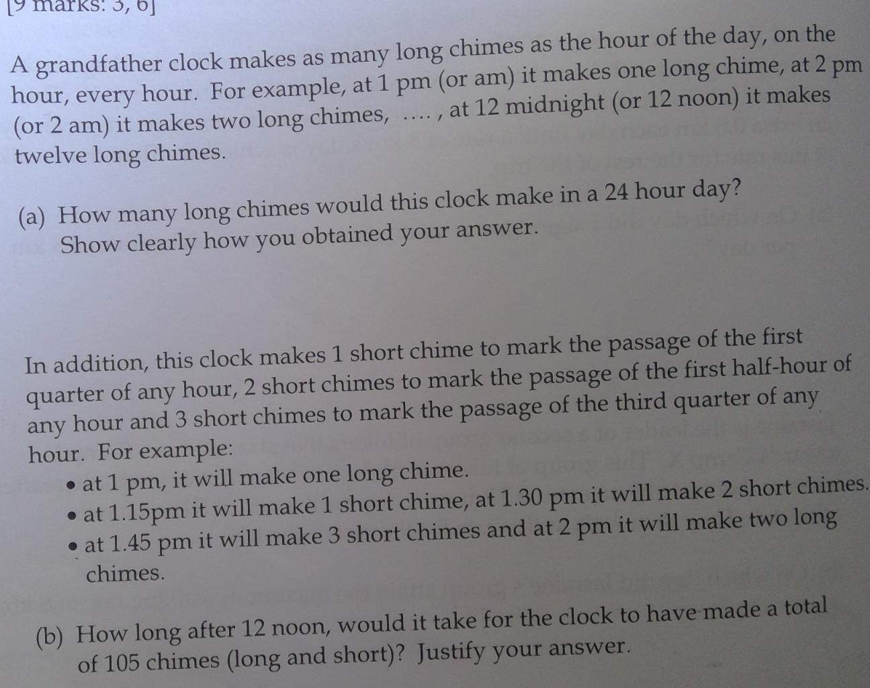
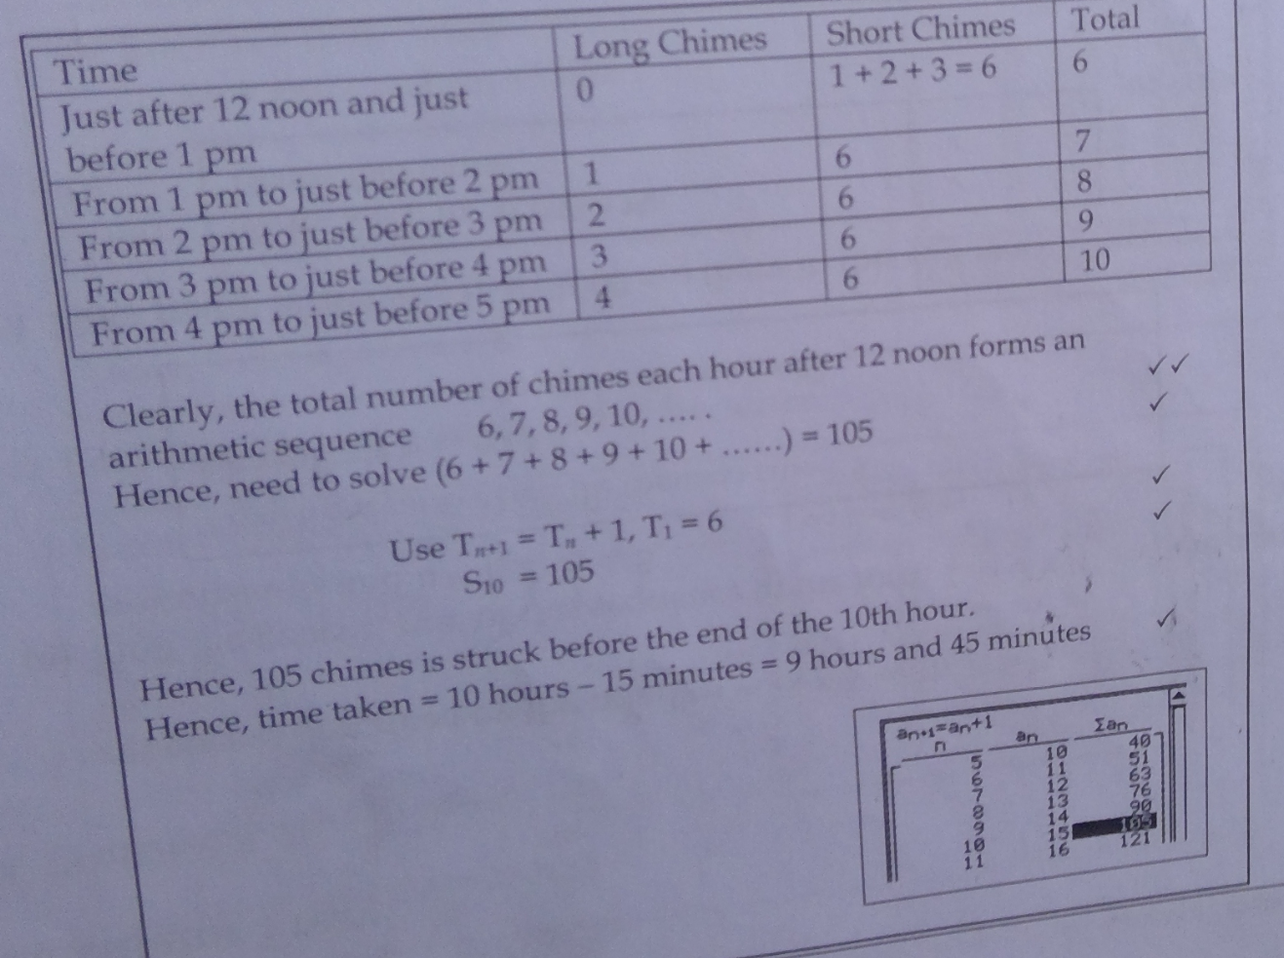

26/10/2020
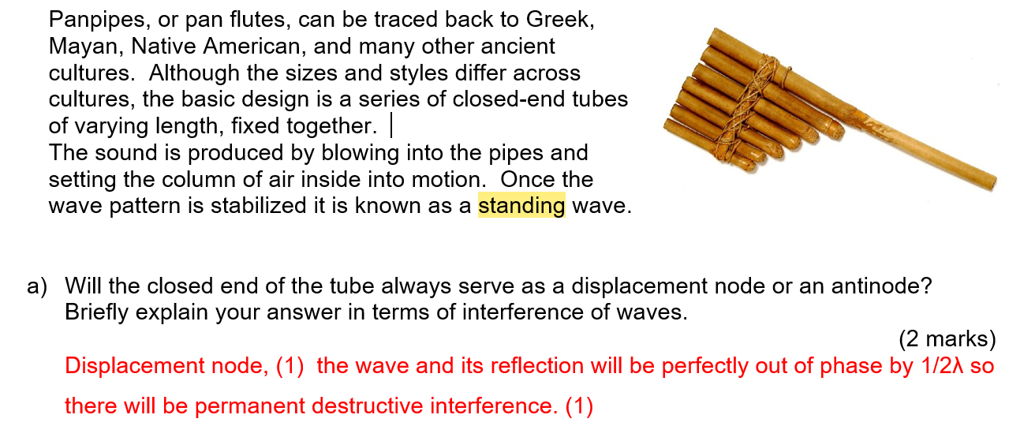

Is sound loudest at pressure antinodes?

Open pipes have displacement antinodes/pressure nodes on both ends, and closed pipes have displacement nodes/pressure antinodes on closed ends and displacement antinodes/pressure nodes on open ends, and sound is loudest at pressure antinodes.

If this statement is true, then why is this question’s answers like this:
Q: Rebecca and Pamela set up a resonating air column in the laboratory sing a 440 Hz tuning fork. The pipe was 1.20m in length. Beginning at one end of the pipe they found:
[i] Maximum intensity at 0m, 0.4m and 0.8m.
[ii] Minimum intensity at 0.2m and 0.6m.
[c] Did the 2 students use an open or closed pipe as a resonating air column? Explain.
They used an open pipe since the next antinode would occur at the other end of the pipe.

(They’re saying that because there’s maximum intensity at both ends, it must be an open pipe, but that means there are pressure antinodes at both ends, whereas with open pipes the ends should be pressure nodes/displacement antinodes).
Q: Dolphins can locate objects by emitting sounds of up to 150 kHz in short pulses.
[a] Assuming the velocity of sound in sea water is to be 1530ms⁻¹, determine the wavelength of these sounds.
λ = $\frac{1530}{150 x {10}^{3}}$ = 1.02 x 10⁻² m

[b] What would be the minimum sized object the dolphins could easily detect by this method? Explain.
Objects about 10cm or greater would be most easily detected.
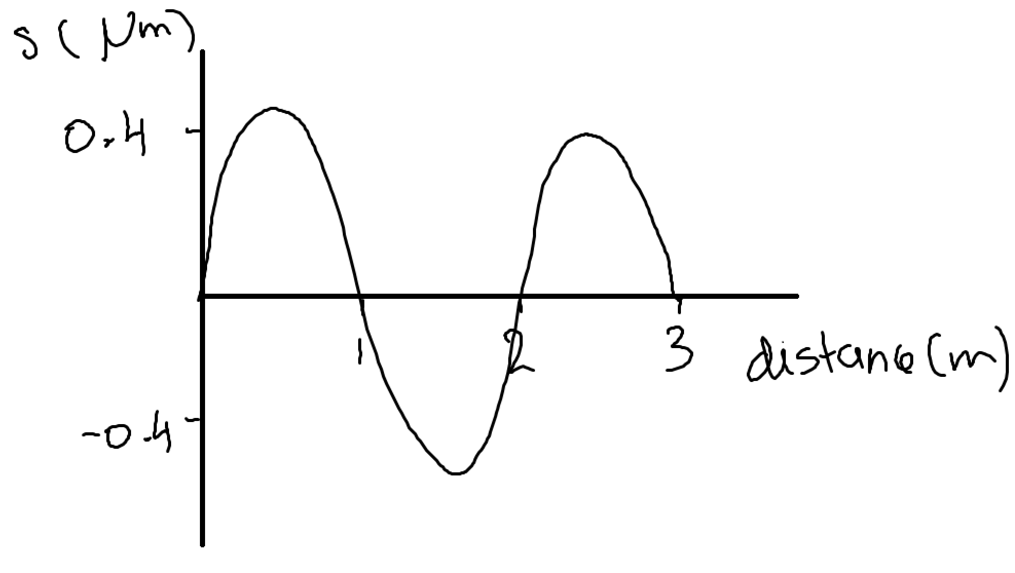
Redraw the diagram above to show how it will look at t = $\frac{T}{2}$.
t = $\frac{1}{2f}$ = $\frac{λ}{2v}$ = $\frac{2}{2 x 340}$ = $\frac{1}{340}$
s = $\frac{1}{340}$ x 340 = 1 → draw 1m after
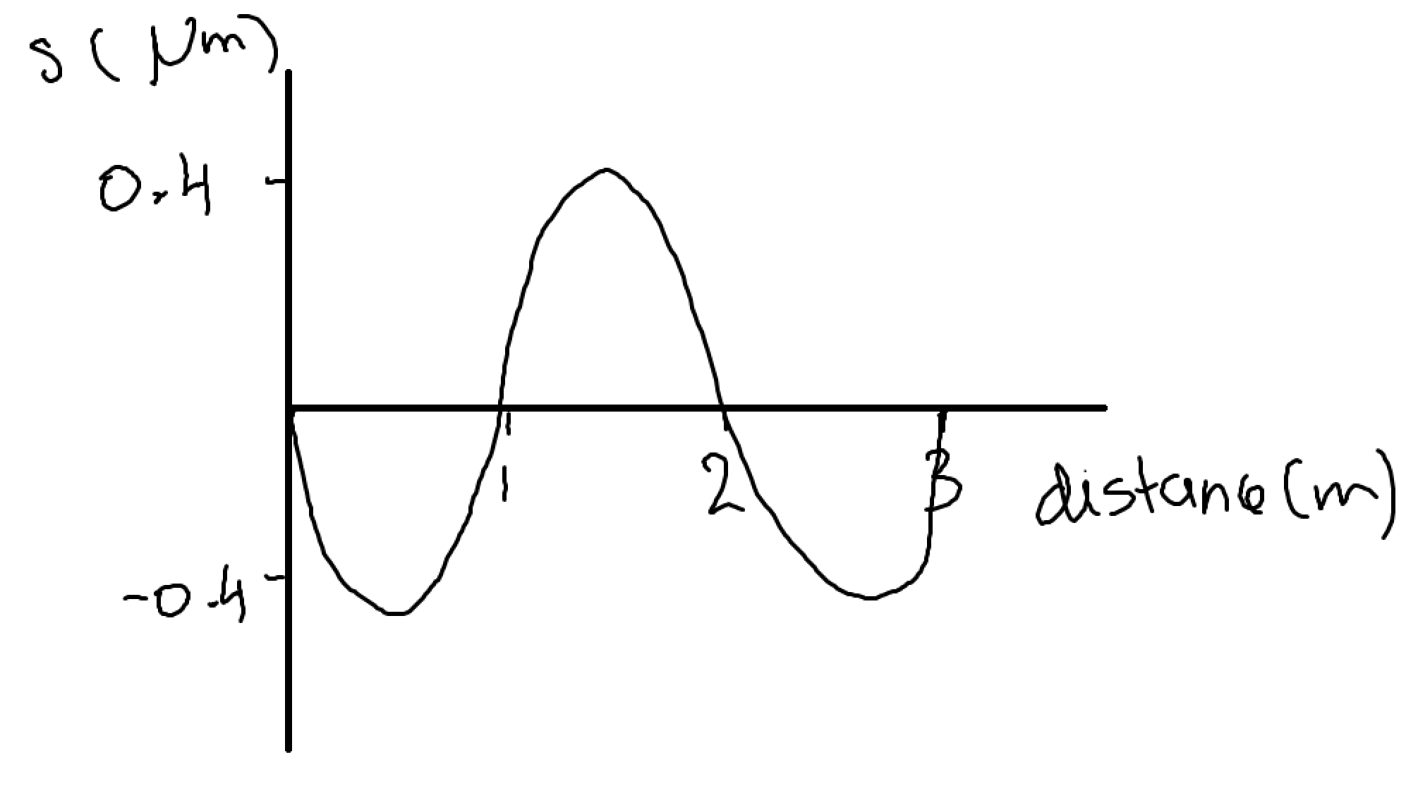
Q: A loudspeaker emits a sound of 1.00 kHz towards a microphone. The microphone is 2.00m from the speaker. Assume the speed of sound is 340ms⁻¹.
[a] Determine the wavelength of the sound being emitted.
λ = $\frac{340}{1000}$ = 0.340m

[b] Draw a graph to show how air pressure varies with distance from the microphone 4.00ms after the commencement of the sound. Assume that initially a compression wave leaves the cone. Pressure levels are arbitrary.
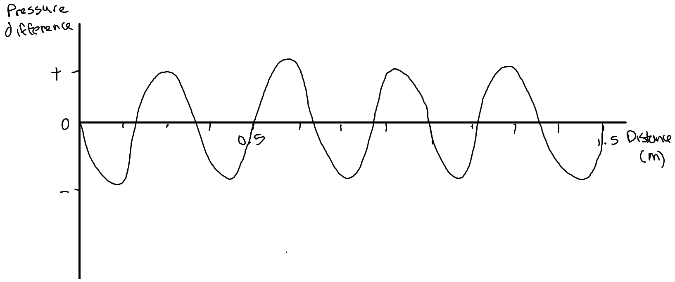
T = $\frac{1}{1000}$ = 0.001 → draw 4 waves → λ = $\frac{340}{1000}$ = 0.340m → draw with compression leaving → start drawing
[c] How long will it take sound to reach the microphone after the commencement of the sound?
t = $\frac{2}{340}$ = 5.88 x 10⁻³ s

[d] Sketch a pressure difference versus time graph as would be recorded at the microphone for the first 0.010 seconds of sound emitted by the speaker. 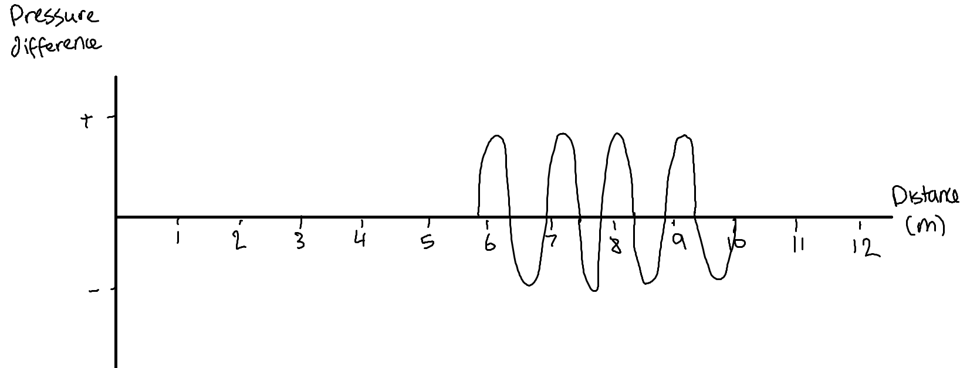
T = 1000⁻¹ = 0.001 → number of waves = $\frac{0.01}{0.001}$ = 10 → λ = $\frac{340}{1000}$ = 0.34 → s = 340 x 0.01 = 0.34m → start drawing at 0.34m on the x-axis.
Q: Paula and Jake use a frequency of 685 Hz. Paula walks along the line from R to T and notices that maximum sound intensities occur at R and T (directly in front of the speakers) and at S (a point equidistant from each speaker). Quiter spots are noticed in between.
T
R
S
B
A
1.60m

[a] What’s the cause of this effect? Explain clearly.
Constructive and destructive interference causing loud and quiet spots.

[b] From the diagram, determine the difference in the distance between AT and BT.
2.30m
T
A
BT = $\sqrt{{1.6}^{2}+{2.3}^{2}} = 2.80m$
1.60m
B
1.6² + x² = (x + λ)²

[c] Use your result in (b) to determine the velocity of sound during this experiment.
Since point T is a maximum, then BT > AT by one wavelength.
v = fλ = 685 x 0.5 = 342ms⁻¹

Q: The nearest air molecule moving in phase with molecule X is 1.40m away. What’s the wavelength of this sound wave?
λ = 1.40m

0.5^{n–1} > $\frac{1}{32}$

31/10/2020
Will I lose marks for showing my working to get a net ionic equation?
Is it legal to put some of your school material on a Google Drive and then share it publicly?
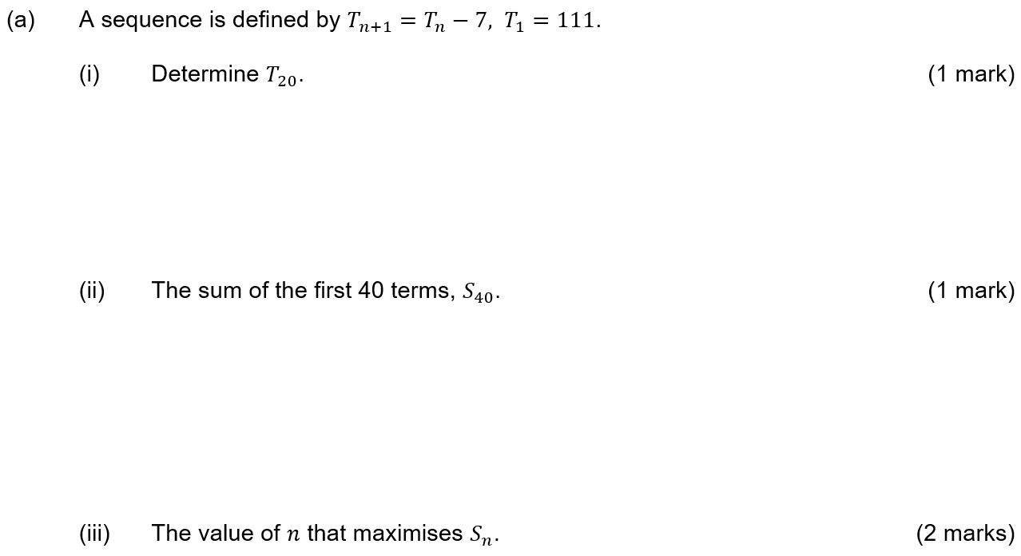

2/11/2020
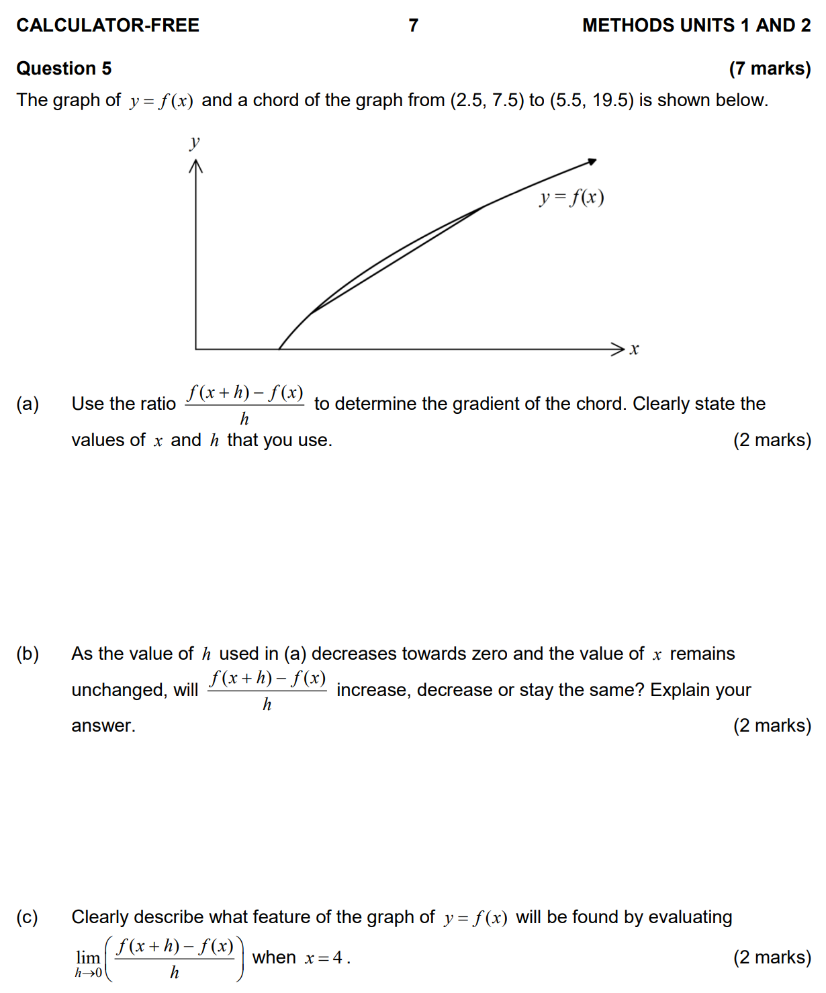
(Parts b and c).
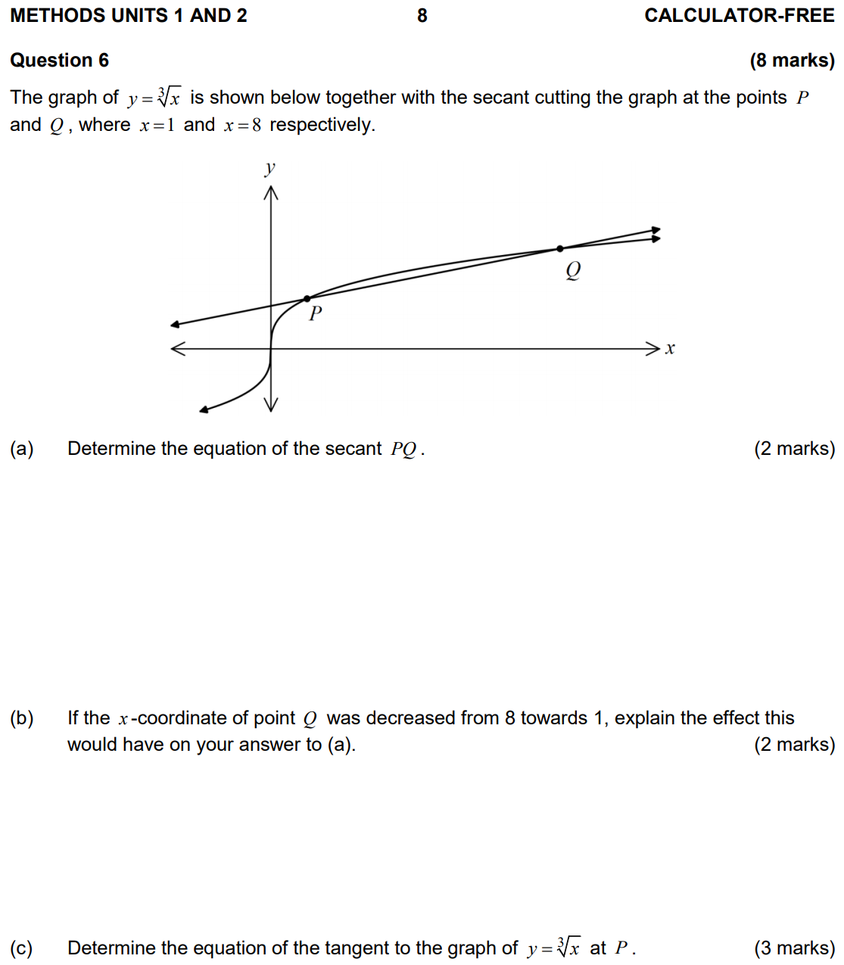
(Parts b and c).

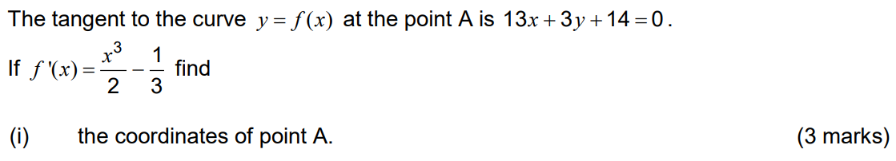

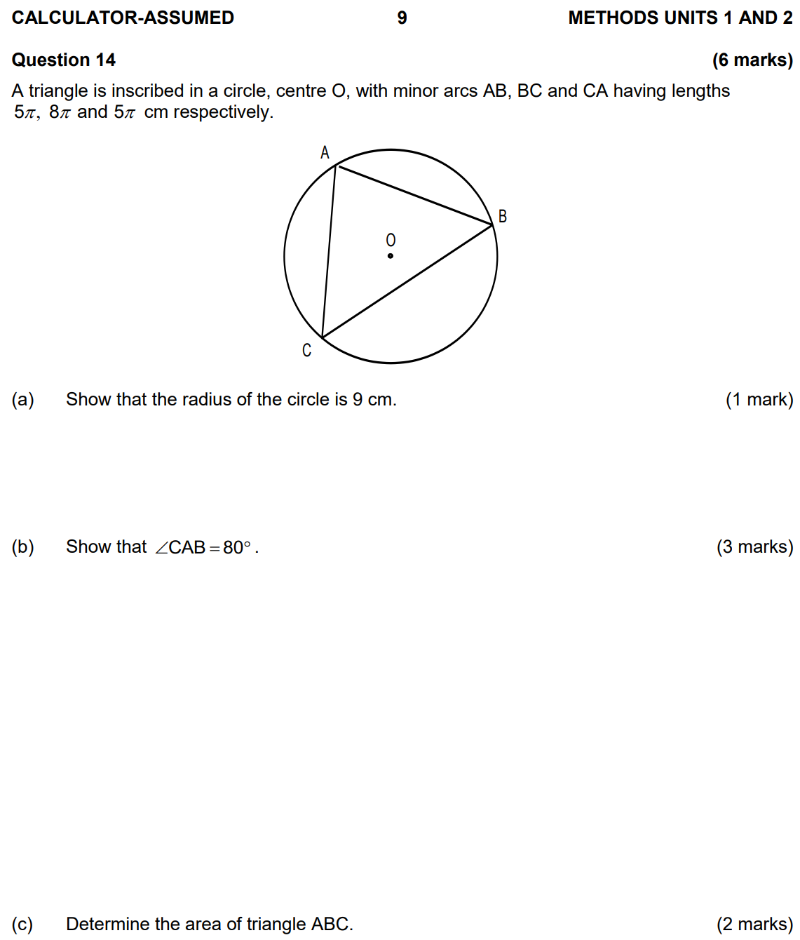
If it says “determine the coordinates of all the stationary points of the function” do I need to determine the nature of the turning points as well?

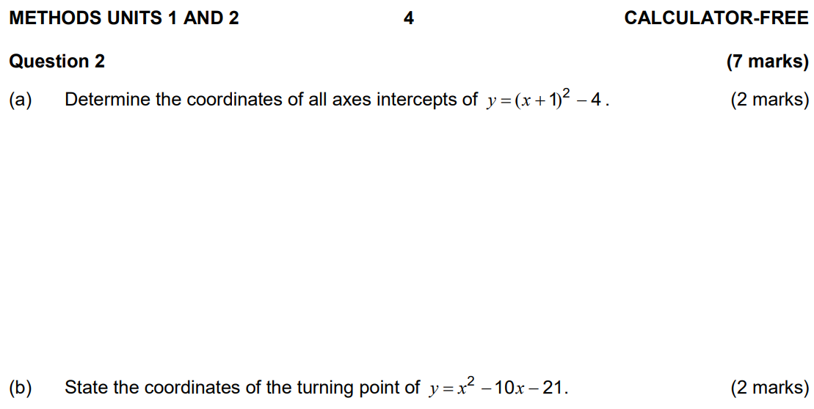
(Am I supposed to use calculus for part b?).

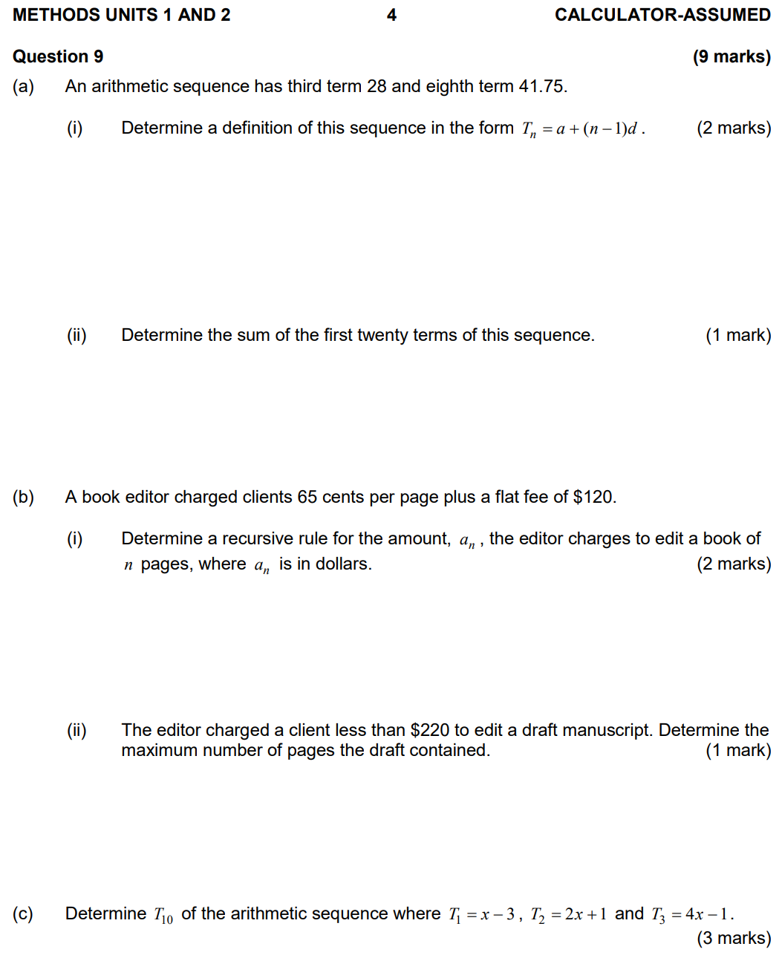
(Part c).
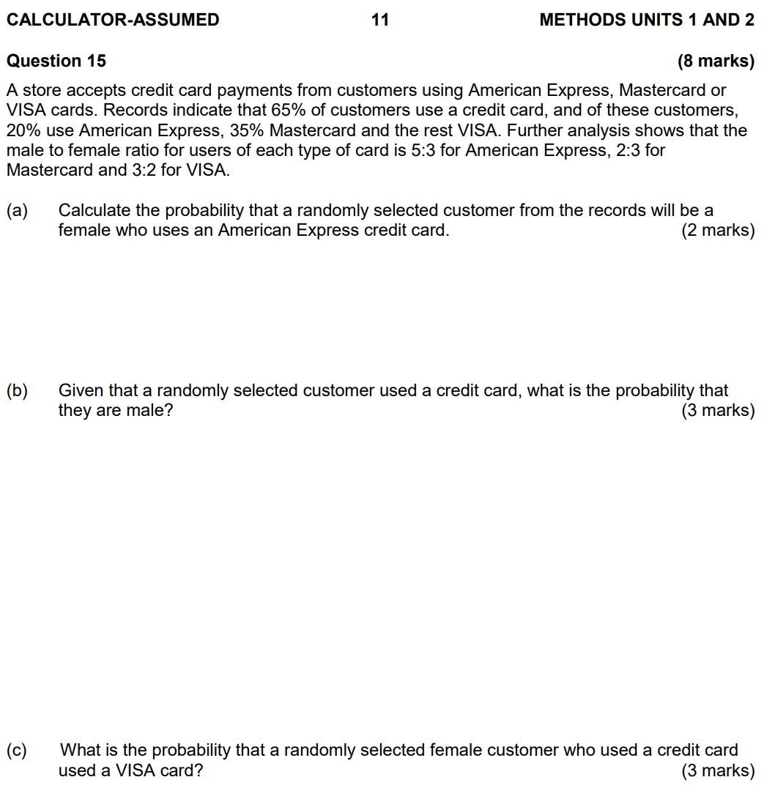
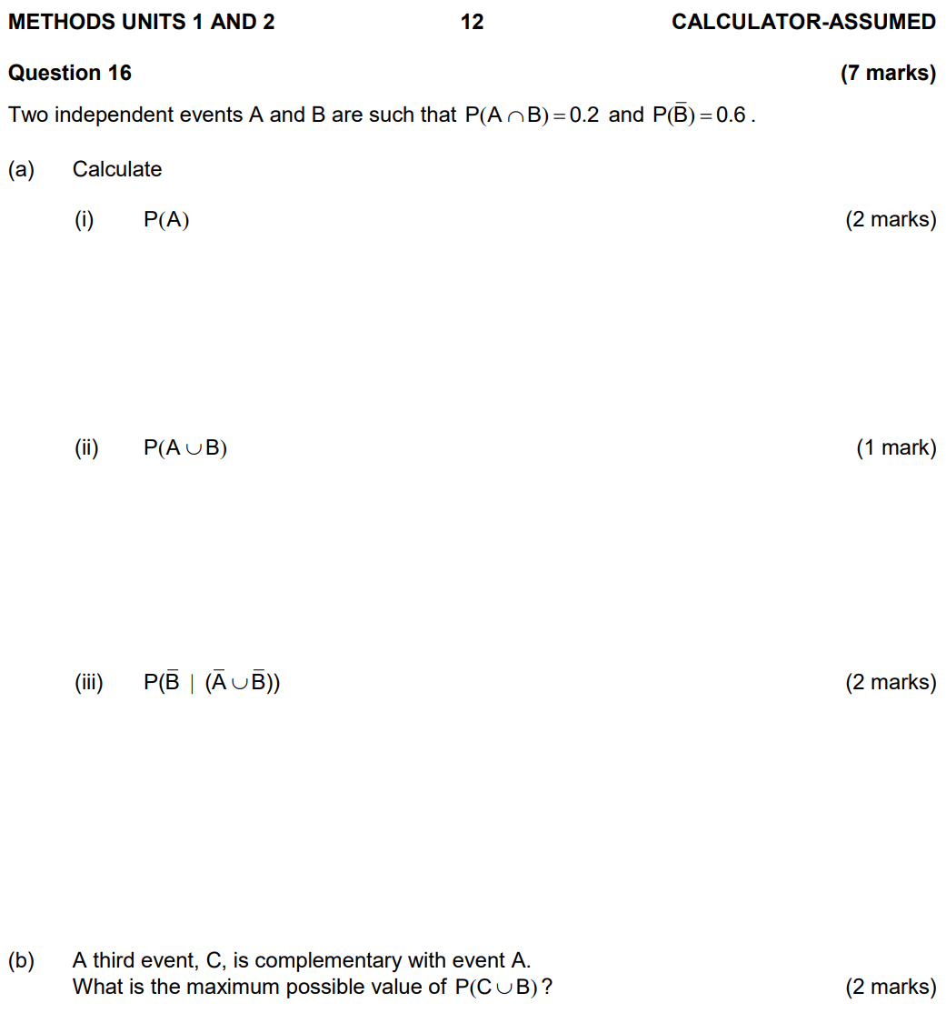
(Part b).
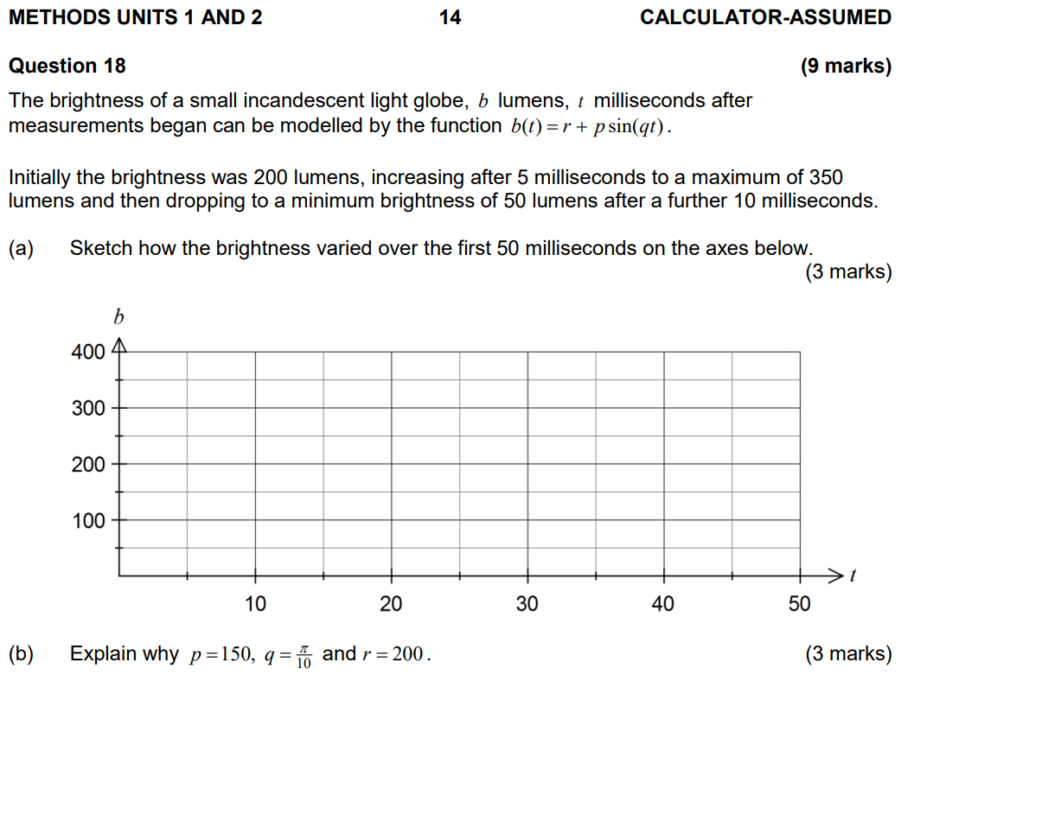
(Would I just say amplitude = p = 150?)

Dilation parallel to the x-/y-axis by scale factor ___.
Would I get full marks for drawing out Pascal’s triangle and getting my coefficients straight form there without doing the ^{n}C_{r} stuff?
Domain and range notation.
How do I write the domain/range if there’s no restrictions to the domain/range?

9/11/2020
Does the range correspond to a given domain?
Does “percentage growth rate” include the 100%? i.e., 101% growth or 1% growth?

In which of the following pairs of substances will hydrogen bonding not occur?
[a] HF and CH₃CH₂OCH₂CH₃
[b] NH₃ and CH₃NH₂
[c] CH₃COOH and CH₃COCH₃
[d] CH₃CH₃ and CH₃CH₂OH

Why do metals have low melting and boiling points?

If a question gave the height of the peaks with the corresponding isotopic mass, how would I find the relative atomic mass (A_{r})?

Would saying that R>0 be a valid way of saying why it must be a parallel circuit assuming I get a negative value for resistance when it’s in series (and a positive value for when it’s in parallel)?

When given a displacement vs time graph, is “total displacement” just the final displacement in the displacement vs time diagram?

The imprisonment rate $R$, in number of prisoners per 100 000 people, in the US between the years 1960 and 2000, can be modelled by the following equation, where $n$ is the year.

$$R=85{\left(1.038\right)}^{n-1960}$$
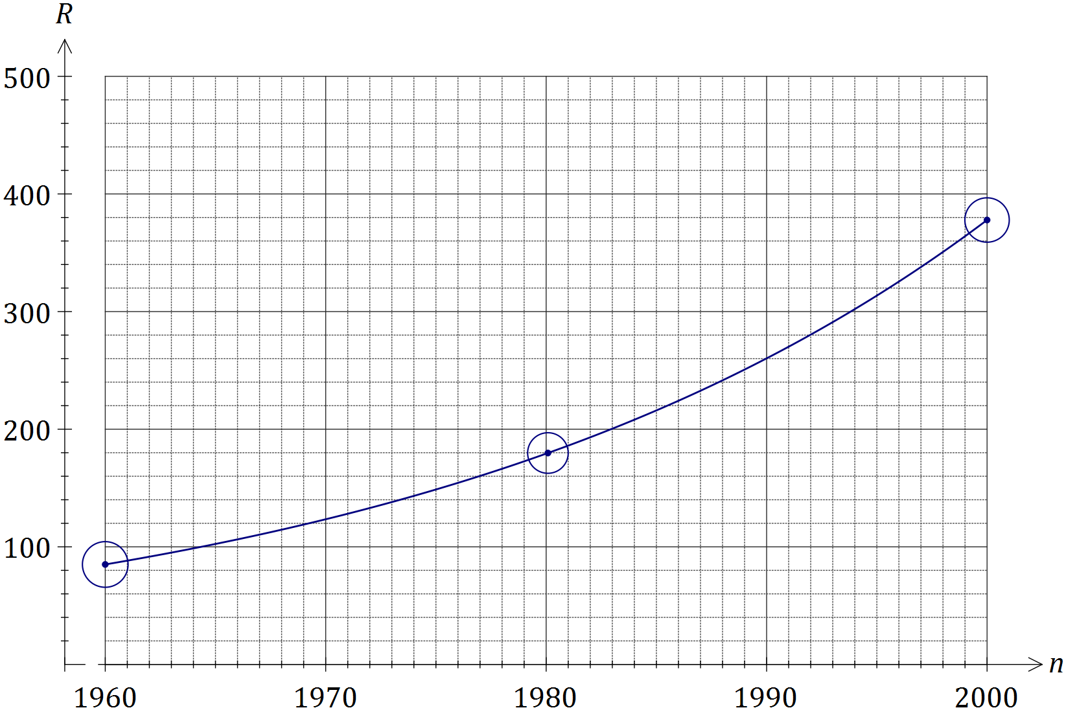
a) The population of the US was 266 million in 1995. Determine the number of prisoners in the US at this time, to the nearest 1 000.
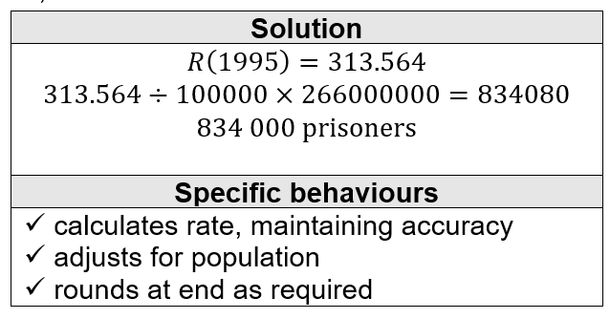
b) When $R$ first exceeded 500, steps were taken to address the exponential growth in the prison population and the model no longer applied. In what year did this occur.
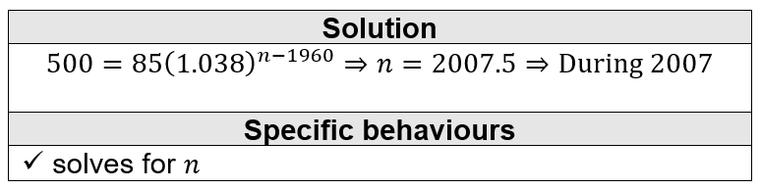
(All of part a, and why is it not during 2008 for part b?)
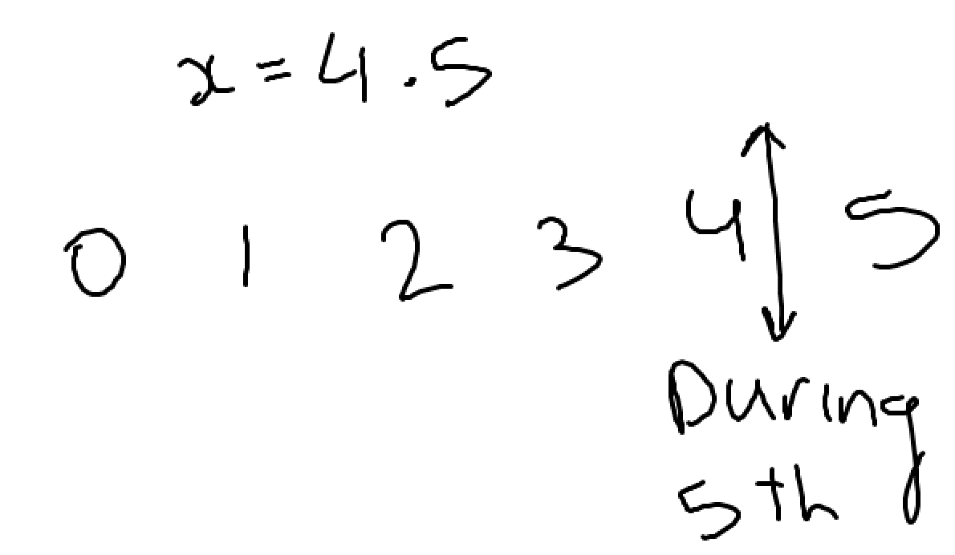
2017 Calc-free:
The graph of $y=f(x)$ is shown below, where $f\left(x\right)=\sqrt{2x+1}$.
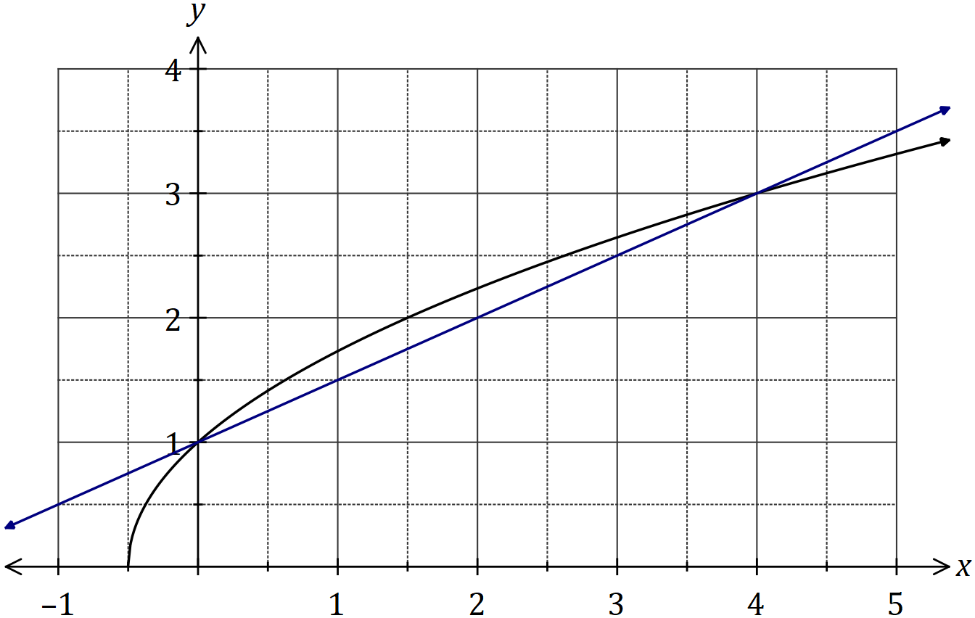
The difference quotient is shown here:
$$\frac{f\left(x+h\right)-f(x)}{h}$$
Evaluate the difference quotient as $h→0$ to determine the slope of $f(x)$ when $x=0$.
$\frac{\sqrt{2(x+h)+1}-\sqrt{2x+1}}{h}$ = $\frac{\sqrt{2x+2h+1}-\sqrt{2x+1}}{h}$
$\frac{\sqrt{2x+2h+1}-\sqrt{2x+1}}{h}$|x=0 → $\frac{\sqrt{2h+1}-\sqrt{1}}{h}$ = $\frac{\sqrt{2h+1}-1}{h}$ x $\frac{\sqrt{2h+1}+1}{\sqrt{2h+1}+1}$ = $\frac{2h+1-1}{h(\sqrt{2h+1}+1)}$ = $\frac{2h}{h(\sqrt{2h+1}+1)}$ = $\frac{2}{\sqrt{2h+1}+1}$
$\frac{2}{\sqrt{2h+1}+1}$|h=0 → difference quotient = $\frac{2}{\sqrt{1}+1}$ = $\frac{2}{2}$ = 1
(Why do we substitute x=0 before h=0?)

The temperature $T$ of a cast taken out of an oven cools according to the model $T=840{\left(0.94\right)}^{t}$, where $t$ is the time in minutes since the cast was removed from the oven. $T$ is measured in $°C$.
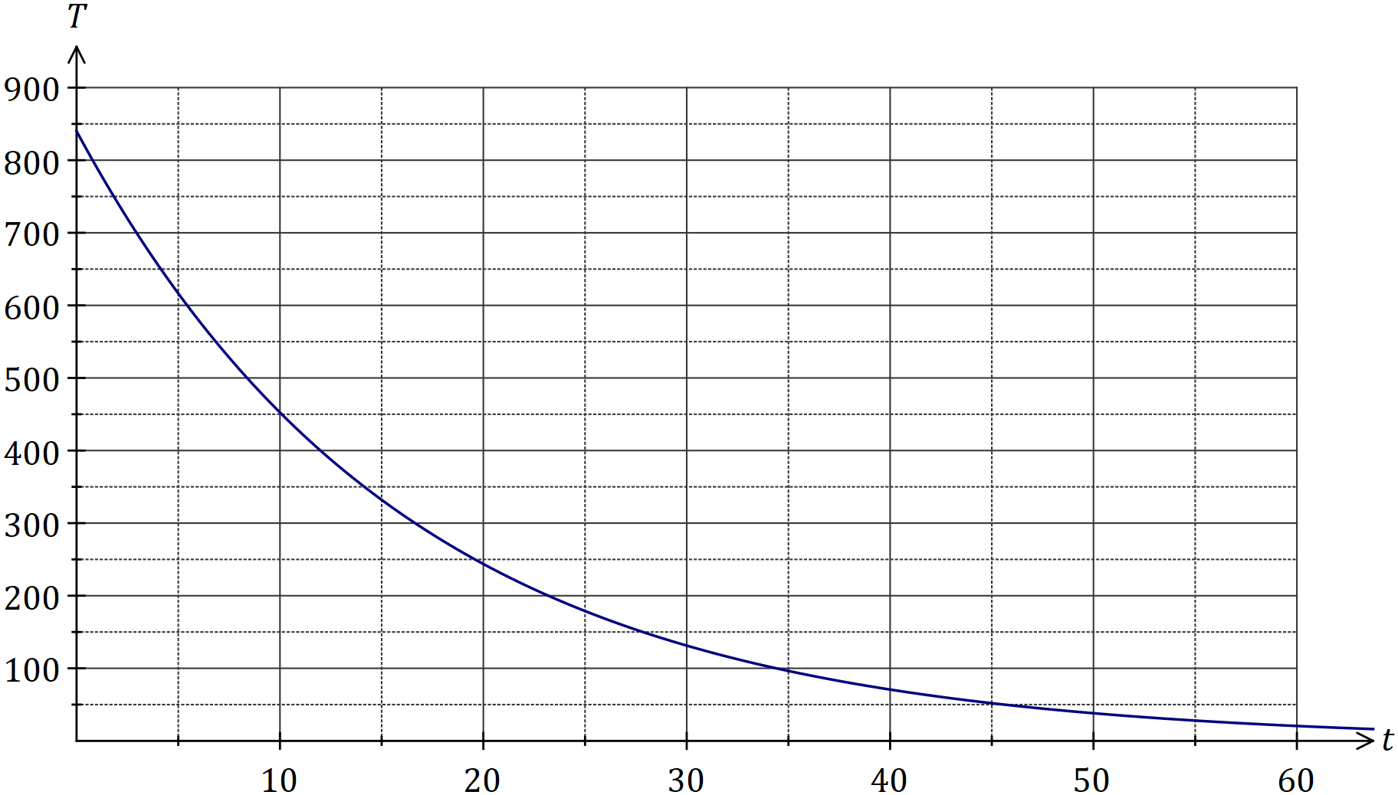
The temperature of the cast falls to room temperature of$15°C$.
a) Determine the time taken for the cast to reach room temperature.
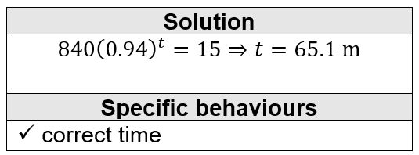
b) Comment on the usefulness of the model for large values of $t$.
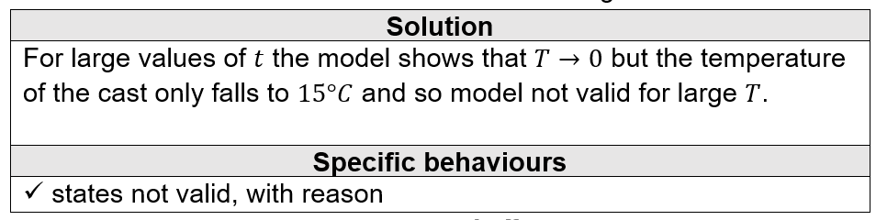
(Part b)

When would I put 100.01% and when would I put 0.01%?
I’d say that growth rate would be 0.01% but I’m not sure what 100.01% would be.

Two water containers, initially empty, are being filled with water. The amount of water added to container $A$ each minute follows an arithmetic sequence, with $3$ mL poured in during the first minute and $6$ mL poured in during the second minute. The amount of water added to container $B$ each minute follows a geometric sequence, with $2$ mL poured in during the first minute and $2.2$ mL poured in during the second minute.
Container $B$ first holds more water than container $A$ at the end of minute $m$.
a) Determine the value of $m$.

$\frac{n}{2}$(6 + (n–1)3) = $\frac{2(1–1.1^{n})}{1–1.1}$ → n = 58.38 → 59 minutes
(n also equals 0.288)

2019 Calc-assumed:
A fair six-sided dice numbered $1, 2, 3, 4, 5$ and $6$ is thrown $n$ times until it lands on a $6$.
a) Determine the probability that the first $6$ is thrown in $12$ or less attempts
b) The probability that the first $6$ is thrown in $k$ or less attempts must be at least $99\%$. Determine the least value of integer k.
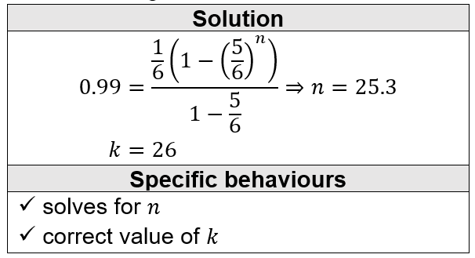
(How do you know whether to round up or down other than substituting n=25 and n=26?)

Is this correct:
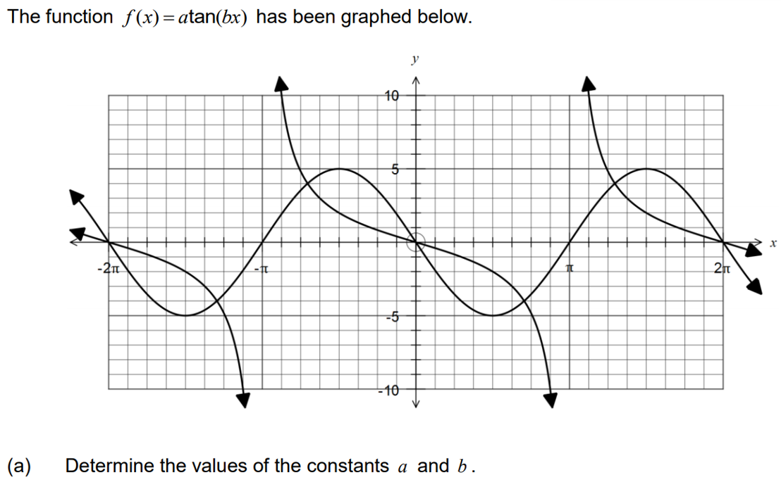
b = $\frac{1}{2}$
($\frac{π}{2}$ , –2) → –2 = a tan($\frac{1}{2}$ x $\frac{π}{2}$)
–2 = a tan($\frac{π}{4}$) → a = –2

OR:
b = $–\frac{1}{2}$
($\frac{π}{2}$ , –2) → –2 = a tan($–\frac{1}{2}$ x $\frac{π}{2}$)
–2 = a tan($–\frac{π}{4}$) → a = 2

(Is the lower half correct?)

Is this correct:

The diagram shows five congruent semicircles standing on the inside of a regular pentagon with sides of length 20 cm. M is the midpoint of the side AB and P is the point of intersection of two semi-circles.
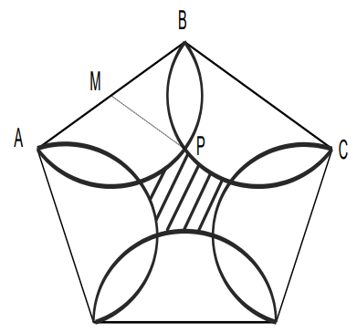
θ
a) Show that the size of angle ∠BMP = 72°.
r = BM = 2cm
θ = $\frac{540}{5}$ = 108°
∠BMP = $\frac{360–2(108)}{2}$ = 72°
(Why not perpendicular?)

b) Determine the area of the central shaded region.
Area(1 segment) = $\frac{1}{2}$(2²)$\frac{72π}{180}$ – $\frac{1}{2}$(2²)sin($\frac{72π}{180}$) = 2.47cm²
Area(all segments) = 10 x 2.47 = 24.7cm²⁺
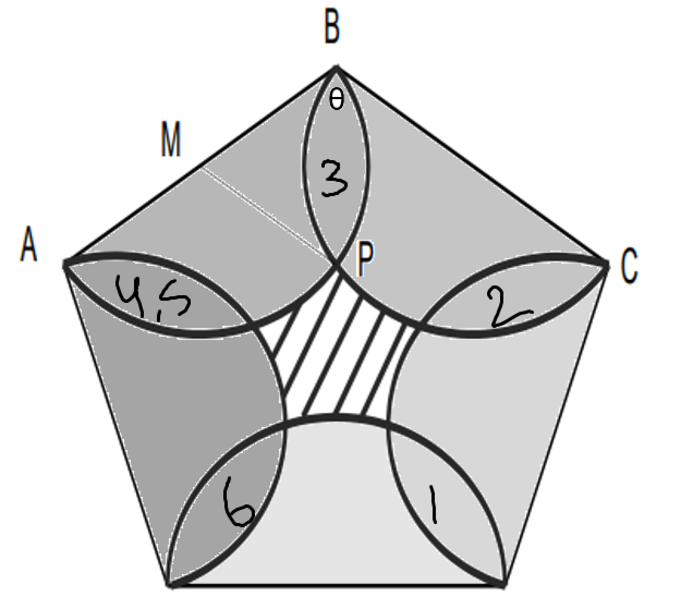

Area(semicircles) gives 6 overlaps of 2 segments → 12 segments
Area = 5($\frac{1}{2}$π2²) – 12(2.47) = 1.78cm²
Area(pentagon) = $\frac{–900sin(\frac{2π}{5})}{5cos(\frac{2π}{5})–5}$ = 247.75cm²
Area(shaded) = 247.75 – 1.78 = 245.97cm²

A person deposits $1000 on 1 January 2015 and a further $1000 on 1 January of each subsequent year up to and including 2024. The investment gains interest at 7% per annum compounded annually. How much will be in the account when it is closed on 31 December 2024? Give your answer to the nearest dollar.
Answer: $14784

